This page has been intentionally left blank.

Epi Info™ Guide to Visual Dashboard

Epi Info™ 7

Preface
Epi Info™ is a public domain suite of interoperable software tools designed for the global community of public health practitioners and researchers. Perform data analysis with epidemiologic statistics, maps, and graphs. Build data entry forms, construct a database, and customize statistics applications. Physicians, epidemiologists, and public health officials without a technical background can easily work with critical data using Epi Info™ tools.
Use this guide alone or as a supplement to other Epi Info™ guides. On the next page, view the complete collection of helpful guides available for Epi Info™ tools. The diagram shows how this guide, highlighted with the bookmark icon fits into the big picture of the Epi Info™ suite. Additional guides may offer prerequisite information for the tool you’re working with. For example, if you’re working with Epi Info™ Visual Dashboard, you’ll find it helpful by referencing the Epi Info™ Guide to Classic Analysis, Stat Calc, and Epi Map. The image below highlights the Guide to Visual Studio with the prerequisite documentation icon (). You may find helpful other optional guides that are highlighted by the optional documentation icon ().

The image below shows the interrelationships among the guides in the series. This guide is Getting Started with Epi Info™ Guide to Visual Dashboard.
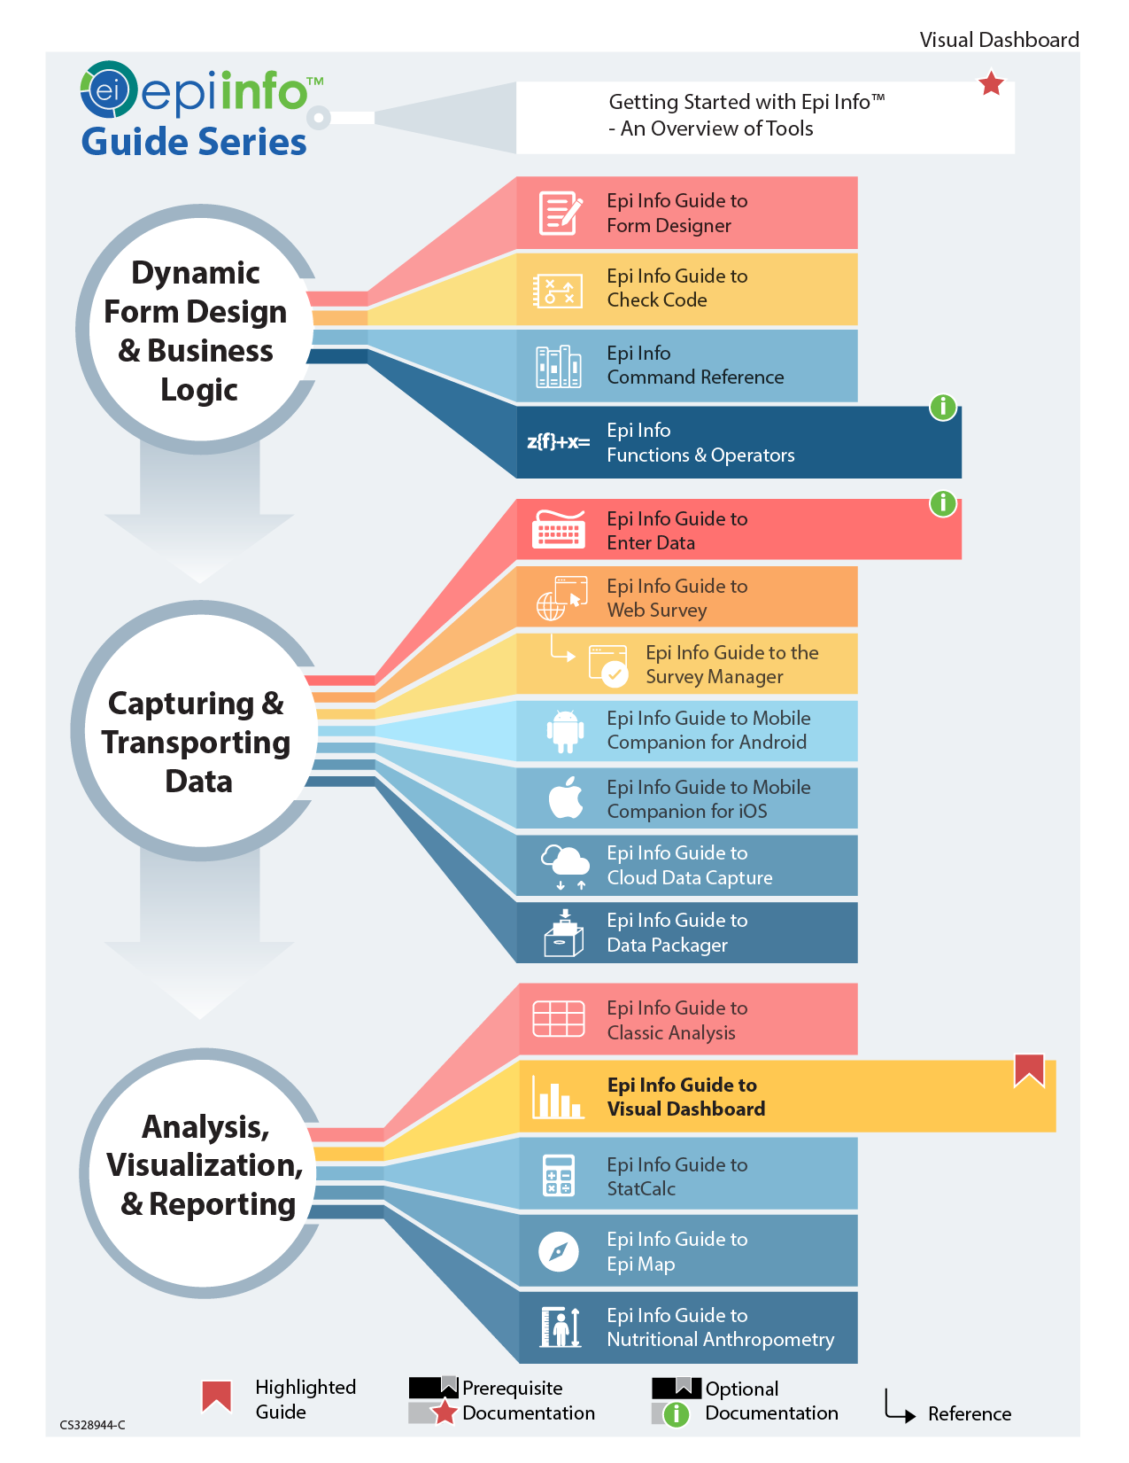
TABLE OF CONTENTS
Preface i
Overview i
Navigating the Canvas iii
Visual Dashboard Navigation iii
Settings: 4
Features List: 5
Canvas Properties 5
Opening the Options Menu 6
Updating the Canvas with Refresh 7
Run from Command Line 7
Selecting a Data Source 8
Working with File Types 11
Read an Epi Info™ 7 Project File 11
Read a Microsoft Excel File 12
Read a Microsoft Access File 12
Read a CSV (ASCII) File 13
Read a Microsoft SQL Server Database 13
Read a MySQL Server Database 14
Add a Related Data Source 15
Analysis Gadgets Error! Bookmark not defined.
General Analysis Gadgets Error! Bookmark not defined.
Using Canvas Controls 17
Open Canvas 17
Save Canvas 18
Save Canvas As 19
Save Visual Dashboard HTML 20
Send Visual Dashboard Output 21
Microsoft Excel 21
Microsoft Word 21
Defining New Variables 21
Creating a New Variable 22
With Recoded Value 22
With Simple Assignment 28
With Conditional Assignment 30
With Formatted Value 36
With Assigned Expression 38
Creating a Variable Group 39
Edit Variable 41
Delete Variable 42
Adding and Removing Data Filters 43
Add a Filter 43
Remove Selected Filter 46
Clear All Filters 47
Advanced Filter Mode 47
Displaying Statistics and Records 49
Summary of Analysis Gadgets 49
Line List Introduction 51
Sorting Records 53
Sorting a List by Column Name 53
Sorting a List Using Line List Grouping and Sorting Properties 54
Remove Sort Criteria 57
Other Line List Properties 58
Exporting a Line List 59
Frequency 63
Frequency Additional Options 65
Word Cloud 69
Combined Frequency 71
Combined Frequency Advanced Options 73
M x M/ 2 x 2 Table 76
Matched Pair Case-Control 78
Means 81
Duplicates List 83
Analysis Gadget Charts 85
Column Chart 86
Line Chart 87
Area Chart 88
Pie Chart 89
Aberration Detection 91
Pareto Chart 94
Scatter Chart 96
Epi Curve Chart 97
Linear Regression 99
Linear Regression Properties 101
Logistic Regression 102
Complex Sample Frequencies, Tables, and Means 106
Complex Sample Frequencies 106
Complex Sample Means 110
Complex Sample Tables 113
Gadget Configuration Settings 117
Line List 118
Moving and collapsing the Line List 121
Sending line list output to other programs 122
Frequency 122
Additional Frequency Gadget Properties 125
Variables 125
Grouping And Sorting 125
Display 125
Data Filters 127
Means 127
MxN/2x2 Table 131
Data Dictionary 135
Show Data Dictionary 135
Open Data Dictionary as an HTML page inside a web browser 136
Additional Gadgets for Reports 137
Simple Text Box and the Image Gadget 137
Simple Text Box 137
Image Gadget 138

Visual Dashboard: Performing Statistical Analyses with Visual Tools

Overview
Visual Dashboard is one of the Epi Info™ 7 analysis modules. Visual Dashboard is intuitive and simple to use. It simplifies analytic tasks by reducing traditional coding requirements. Instead, intuitive gadgets sort, list, or manipulate data. Statistical analysis gadgets in Visual Dashboard include frequencies, means, and more advanced statistical calculations (e.g., linear regression and logistic regression). Graphing functionality is native to Visual Dashboard. You can display data as an Epi Curve, Pareto Chart, and several other bar and column charts.
Users can access Visual Dashboard from the Epi Info™ 7 main menu by clicking the Visual Dashboard button.

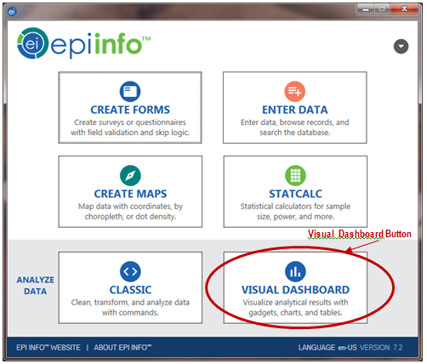
Main menu Navigation

Navigating the Canvas

Visual Dashboard Navigation
Visual Dashboard contains seven areas:

- Canvas
- Canvas Display Mode Selector
- Data Source and Record Count Display
- Canvas Output Controls
- Canvas Tools Toolbar
- Defined Variables Gadget
- Data Filters Gadget

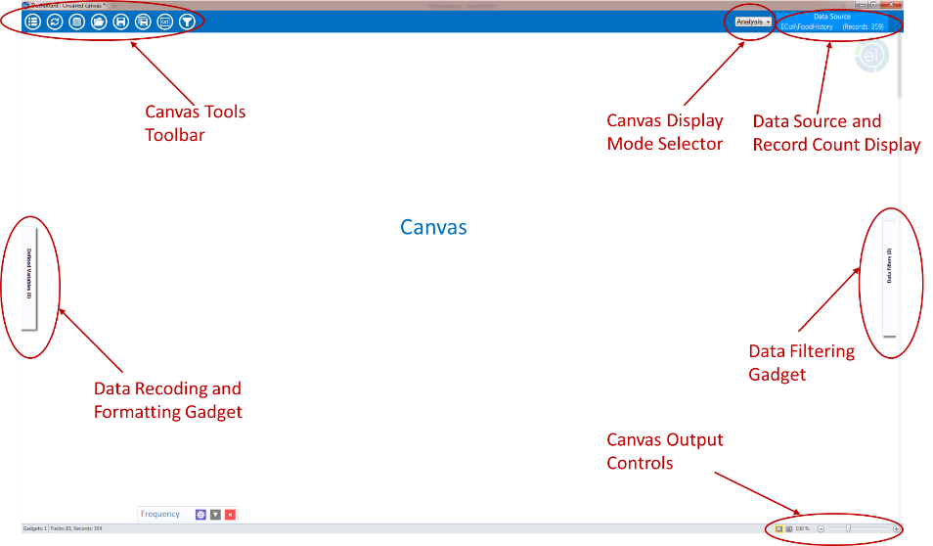
Visual Dashboard canvas

The Canvas is the blank space in the center of the Visual Dashboard. It displays output generated by the multiple gadgets available in the tool. Right clicking on the canvas launches a function dialog box.
The Canvas Display Mode is in the upper right corner of Visual Dashboard.

Settings:
- Analysis (default) – Displays analysis gadgets.
- Data – Browse data in the loaded data set in grid format.
- Variables – displays a Data Dictionary for data set variables.
You can find the Data Source and Record Count Display at the top right of the screen, displays the source and record count of the data set. The number of fields (columns) in your data set displays on the bottom left of the Windows status bar.
The Canvas Output Controls are on the bottom right side of the Dashboard workspace. Canvas output controls contain three options.
- Hide Borders button – turns off external borders for each gadget, resulting in a report like appearance.
- Auto-arrange button – positions gadgets on the canvas, maximizing the display area.
- The Zoom Percent and Zoom Slider – zooms in and out over the canvas.
You can create, edit, and delete variables from the analysis session, using the Defined Variables Gadget. The Defined Variables Gadget is in the slide-in drawer on the left side of the canvas. Apply canvas wide filters using the Data Filtering Gadget (or Data Filters). Use it to select data for analysis. The Canvas Tools toolbar is at the top left corner of the canvas.

Features List:
- Options – opens options menu.
- Refresh – refreshes your screen with new data.
- Set Data Source – sets your data source.
- Open – opens a saved canvas.
- Save – saves your current canvas back to the original filename and location.
- Save As – saves your current canvas to a new name or new location.
- Variables – opens the Defined Variables Gadget.
- Filters – opens the Data Filtering Gadget.
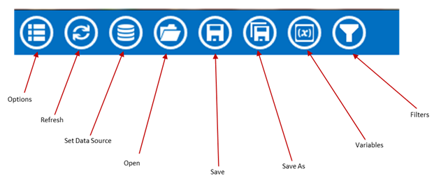
Canvas toolbar

Canvas Properties
Access Canvas Properties after you load a data set. Right clicking on the canvas launches the options menu. Select Canvas Properties.
Use these tools to:
- Change the data source properties by selecting a new project and table.
- Change HTML output properties and create a custom title, summary, and conclusion for your Visual Dashboard output.
- View technical Information about your canvas, such as the number of rows and columns, and cached Information.
Note: Changing the data source in the Canvas Properties is an advanced feature and not recommended unless the schema of both data sources is the same.

Opening the Options Menu
Set the data source. Click the Options menu icon.
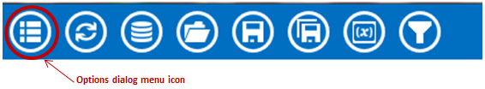
Toolbar highlighting Options menu
The Options menu has many features you can use with a set data source.

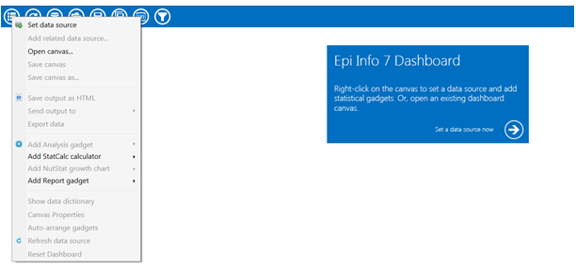
Options menu

Updating the Canvas with Refresh
The Refresh icon updates gadgets with fresh data.

Visual Dashboard toolbar, with Refresh icon circled

Run from Command Line
Run Visual Dashboard from a batch program, custom menu, or command line. Associate the Visual Dashboard executable (visualdashboard.exe) with the CVS7 extension. Open your canvas using its saved file name.
If the .CSV7 file extension is not associated with the Visual Dashboard program, run the AnalysisDashboard.exe program followed by the name of the canvas using the /canvas: switch like this: analysisdashboard.exe /canvas: c:
“myfile.*”
These examples are given with the assumption that Epi Info™ 7 is in the C:\Epi Info 7 folder on a C: drive. If your copy of Epi Info™ 7 is in another location, use your specific file location or a relative path.
You can launch Visual Dashboard by using the run command or through the command line (i.e.: AnalysisDashboard.exe). You can also click on the start icon or shortcut the within the Epi Info™ 7 folder.
Open a specific canvas using the /canvas: switch. In this example, open Visual Dashboard. The saved Ecoli.cvs7 canvas is in C:\Epi Info 7\Projects\Ecoli folder.

Example:
C:\Epi Info 7\AnalysisDashboard.exe /canvas: "C:\Epi Info 7\Projects\Ecoli\Ecoli.cvs7"

Selecting a Data Source
Visual Dashboard works with Epi Info™ 7 project files, CSV files, Microsoft Excel, Microsoft Access, Microsoft SQL Server, MySQL, RedCap, and PostgreSQL. Select a data source by choosing any of the following steps.
Click the arrow in the blue box next to Set a data source now when you open a new canvas.
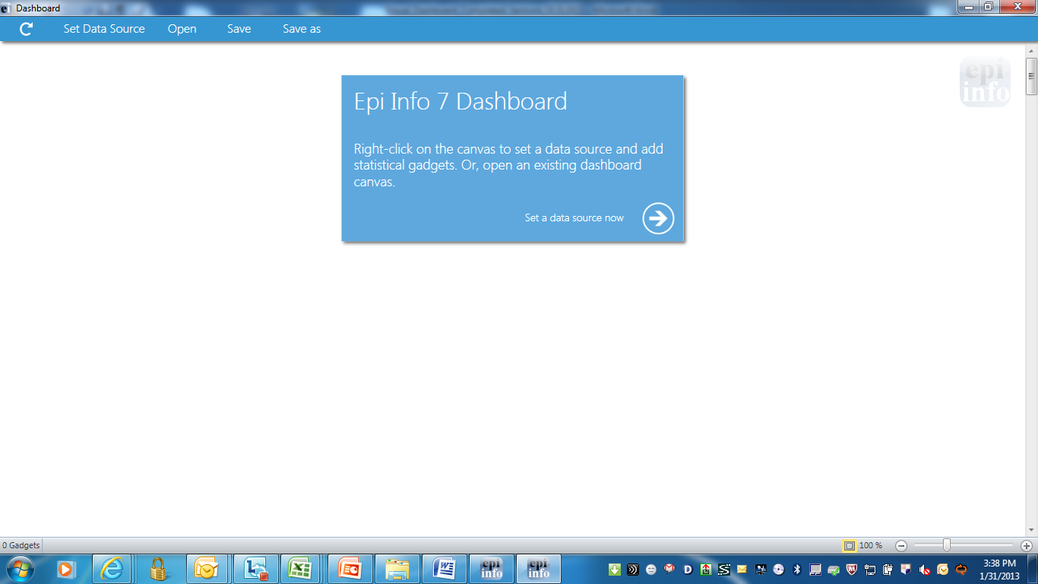
Set a data source
You can click on the Set Data Source icon from the bar at the top of the screen.

Set Data Source icon
You can also right click on the canvas and select Set Data Source from the Options menu.
After selecting the Set Data Source option, the Select Data Source dialog box displays. Select a Database Type, Data Source, and form, to open data in Visual Dashboard. View the following features:
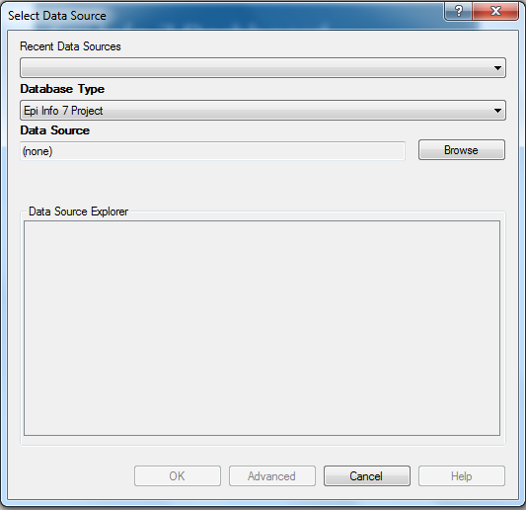
Select Data Source dialog box

Recent Data Sources – lists recently accessed databases from Classic Analysis or Visual Dashboard. You don’t need to know the Database Type or Data Source Information. If you are reading an Epi Info™ 7 project file, all available forms appear in the Data Source Explorer box.
Database Type – field shows database files by database name ( for some the file extension i.e. MDB, XLS are also provided). Specify the format for your data file. Locate output files in the default destination folder.
Data Source – field shows the file location/path. If you use a SQL Server database, the Data Source field requires server and database names.
Data Source Explorer – field allows you to select a project form. Explorer reads the form data table, and the Data Source field shows the file location and path. If you use a SQL Server database, the Data Source field requires server and database names.
Advanced mode – allows SQL queries to select the data source. Currently, Advanced Mode supports select statements only.

Working with File Types

Read an Epi Info™ 7 Project File
- Set a Data Source by clicking the Set a Data Source now arrow, click the Set a Data Source icon, or right click and select Set a Data Source. The Select Data Source dialog box displays.
- Select an Epi Info™ 7 Project from the Database Type drop-down list,
- Click browse next to the Data Source field. The Epi Info™ 7 project folder displays.
- Browse for your project file in Visual Dashboard. If your project is in a pre-selected folder, go to the folder and then open your project (PRJ) file. Epi Info™ 7 comes with some sample projects like Ecoli.prj. Click Open.
- Select a form. The Data Source Explorer box populates with a list of all the forms that are associated with the project.
- Click OK. The record count and data sources appear in the toolbar. Don’t see it? Look at the top right of the canvas.
- Click OK. The Processing Finished message displays, showing that the system has cached the data. Perform analysis on your data.

Read a Microsoft Excel File
- Click Set a Data Source Now arrow. The Select Data Source dialog box displays.
- Select either MS Excel 97-2003 Workbook or MS Excel 2007 Workbook, from the Database Type drop-down list,
- Click Browse, next to the Data Source field. The Open Existing File dialog box displays.
- Enter the filename and path to open your workbook or click Browse to search for the MS Excel workbook (XLS or XLSX extension).
- Click Open. The First row contains header information. The checkbox is selected by default. If this option is unchecked, imported data won’t have column headings.
- Click OK, then select a worksheet from the list in the Data Source Explorer window.
- Click OK. The record count and data source appear in the menu bar. Can’t see it? Look for it at the top right of the Visual Dashboard canvas.

Read a Microsoft Access File
- Click Set a Data Source now arrow. The Select Data Source dialog box displays.
- Select either MS Access 2002-2003 (MDB) or MS Access 2007(ACCDB), from the Database Type drop-down list.
- Click Browse next to the Data Source field. This displays the Open Microsoft Access File dialog box.
- Enter the filename and path to open your file or click Browse to search for the MS Access file (MDB or ACCDB files). You can enter your password if one is set.
- Click OK and select a data table from the list in the Data Source Explorer window.
- Click OK. The record count and data source display in the menu bar at the top right of the Visual Dashboard canvas.

Read a CSV (ASCII) File
- Click on the Set a Data Source Now arrow. The Select Data Source dialog box displays.
- Select CSV File from the Database Type drop-down list,
- Click Browse next to the Data Source field.
- Click Browse in the Flat File Location dialog box to search the directory.
- Select the directory containing the CSV file and click OK.
Note: The First row contains header Information. The box is selected by default. If this option is unchecked, imported data won’t have column headings.
- Select the filename from the list in the Data Source Explorer window.
- Click OK. The record counts and data source appear in the menu bar. Don’t see it? Look at the top right of the canvas.

Read a Microsoft SQL Server Database
Note: You must have Microsoft SQL Server installed on your computer or you must have access to a server over a network to perform this function.
- Click on the Set a Data Source now arrow. The Select Data Source dialog box displays.
- Select Microsoft SQL Server Database, from the Database Type drop-down list.
- Click Browse next to the Data Source field.
- The Connect to SQL Server database dialog box opens. Enter the Server name and Database name.
- The Use Windows Authentication radio button is selected by default. You can use SQL Server Authentication by checking the corresponding radio button and then entering login and password credentials.
- Click OK.
- Select a data table from the list in the Data Source Explorer window,
- Click OK. The record count and data source display in the menu bar. Don’t see it? Find it at the top right of the canvas.

Read a MySQL Server Database
Note: You must have MySQL Server installed on your computer or you must have access to a server over a network to perform this function.
- Click on the Set Data Source arrow. The Select Data Source dialog box displays.
- Select MySQL Database from the Database Type drop-down list,
- Click Browse next to the Data Source field.
- The Connect to MySQL database dialog box displays. Enter the Server name and Database name, username, and password to connect to the MySQL database. You can select <Browse for more> from the Server name drop-down list to select a MySQL server in your network.
- Click OK.
- From the list provided in the Data Source Explorer, select a data table.
- Click OK. The record count and data source show in the menu bar at the top right of the Visual Dashboard canvas.

Add a Related Data Source
Perform analysis in Visual Dashboard data from multiple data sources. The Add a Related Data Source option, links tables or forms using a common identifier. Linking a form or table requires an important field which relates the records together. Currently, the link can only be done using one field. If your common identifier consists of multiple fields, then please review the Classic Analysis User Guide. Forms created in Form Designer or Visual Dashboard relate to each other using the Global Record ID (GLOBALRECORDID) of the first form and the Foreign Key or (FKEY) column of the related form. The demonstration below shows how adding a related data source works.
Epi Info™ 7 contains a related database in the Sample.prj file with two forms named Surveillance(parent). It has three child forms named RHepatitis, RLyme, and RMeningitis. In the example below, we relate Surveillance (parent) to RHepatitis (child).
- Follow the steps to Set a Data Source and select the Sample.prj data source. Open Surveillance.
- Right-click on the canvas and select Add Related Data Source. The Select Data Source dialog box opens. Set a Data Source and select the Sample.prj Data Source, again.
- Select RHepatitis from the list of forms in the Data Source Explorer. The Child Key Field drop-down list populates.
- Select GlobalRecordId, from the Parent Key Field drop-down list.
- Select FKEY from the Child Key Field drop-down list. FKEY is the foreign key in the child form. It matches GlobalRecordId in the parent form.
- Check the Use Unmatched (ALL) checkbox. It includes all records from the primary form, regardless of matching records in related data source. Uncheck the Use Unmatched (ALL) checkbox to include only records represented by keys that match in both tables.
- Click OK. The Processing Finished message displays. The data is now local. Use the data from two tables for analysis.
Note: You can only perform a one-to-one analysis with a related table in Visual Dashboard. To perform a one-to-many analyses, please review the Classic Analysis User Guide.
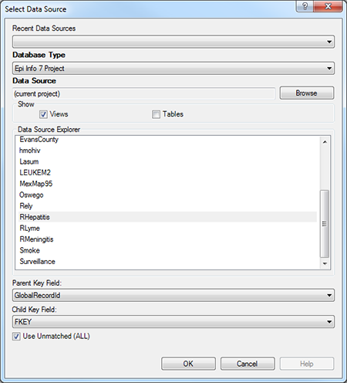
Add Related Data Source dialog box

Using Canvas Controls

Open Canvas
Open an existing Visual Dashboard canvas by selecting the Open icon on the Canvas Tools toolbar. You can also right-click on the canvas to open the Canvas Options dialog. Epi Info™ 7 includes several sample canvas files including Oswego.cvs7.

Toolbar highlighting Open icon

If you don’t see your saved canvas in the Quick Access List, navigate to a saved canvas file using Windows Explorer.
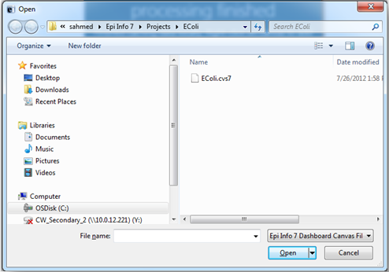
Open a Canvas
When your canvas loads, you’ll see the confirmation message at the bottom of the screen. You can also click the Open file folder icon in the top left corner of the canvas for quick access to saved canvas files.
- Select the location of the canvas file. The file can be identified by the file name extension CVS7.
- Click Open. The canvas displays in Visual Dashboard, connects to the data source, and displays the latest results.
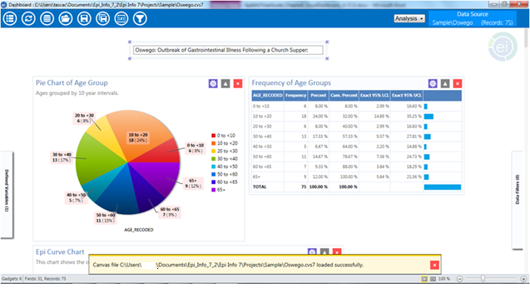
Open Canvas
The Canvas filename displays in the yellow message field at the bottom of the screen. You can also click the open file folder icon in the top left corner of the canvas for quick access to saved canvas files.

Save Canvas
Save the current canvas to include the data source connection, analysis gadgets, data filters, and user-defined variables for reuse. You won’t need to recreate the work previously done during your analysis.
Save the canvas by right-clicking on the canvas. Select Save Canvas. You can also click the Save icons at the top left corner of the canvas.
 Warning! This action will overwrite an existing saved canvas.
- If this is the first time saving your canvas, assign a filename, and choose a file location.

Toolbar with highlighting Save icon

Save Canvas As
The Save Canvas As option allows the canvas to be saved for the first time or saved to a new name or location.
- Right-click on the canvas and select Save Canvas As or click the Save As icon in the top left corner of the canvas. The Save As dialog box displays.
- Select a location to save the canvas and enter a filename.
- Click Save.

Toolbar highlighting Save As icon
Note: If a file with the same name already exists, a confirmation displays, asking if you would like to replace the existing file.

Save Visual Dashboard HTML
You can save your Visual Dashboard output from gadgets as an HTML document. Save your output by right-clicking on the canvas and select Save Output as HTML. The Save As dialog box displays.
Select a location to save the canvas output and enter a filename. The default location for saving output is to the Epi Info™ 7 Output folder.
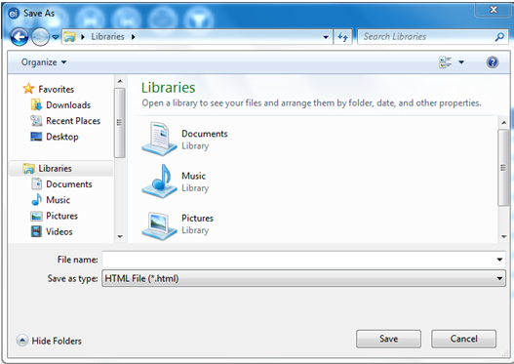
Save output as HTML
Click the Save button. The output opens in the web browser.
Note: Open HTML documents in a Web browser and cannot be used to re-create the Visual Dashboard canvas.

Send Visual Dashboard Output
If you have MS Word and Excel, you can view outputs from Visual Dashboard with the Send Output To option.

Microsoft Excel
- Right-click on the canvas, select Send Output To > Microsoft Excel.
- Visual Dashboard output opens in Microsoft Excel.

Microsoft Word
Right-click on the canvas, select Send Output To > Microsoft Word. The Visual Dashboard output opens in Microsoft Word as an .HTML formatted web document. Saving in this format your charts reside in a sub-folder. When sharing this HTML file, add the sub-folder as well. Alternatively, change the format to a Microsoft Word DOCX format. Then, your charts display with the DOCX file as embedded images.

Defining New Variables
You to create, edit, or delete variables with no coding in the Defined Variables gadget in Visual Dashboard. To access the Defined Variables gadget, move your mouse over Defined Variables on the left-hand side of the screen or by clicking the variable symbol (x) in the Visual Dashboard toolbar.

Toolbar, with Variable button
Defined Variables Gadget Controls:
- Create New Variable
- Recoded Value
- Simple Assignment
- Conditional Assignment
- Formatted Value
- Assigned Expression
- Create Variable Group
- Edit Variable
- Delete Variable

Creating a New Variable
Data isn’t always in the proper format for analysis. As an example, consider analyses for patients by age, using age groups. Some data may contain county codes, but descriptive county names might be more useful. Creating a new variable is a function of the Defined Variables gadget. Create new variables that make your data more useful for analysis. For example, recoding patient ages to age groups in five-year increments or assign county names to county codes. Create new variables and change the formatting of existing data with Recoded Value, Simple Assignment, Formatted Value, Assigned Expression. Then, try grouping existing variables as you wish.

With Recoded Value
The Recoded Value option assigns a value from an existing variable and places the results into a new variable. Click New Variable in the gadget and select With Recoded Value. The Add Recoded Variable dialog box displays.
View the field definitions below the following image.
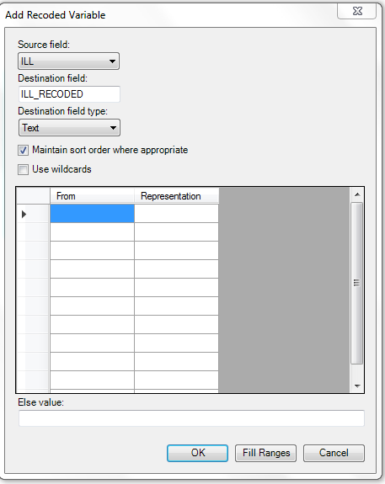
Add Recoded Variable dialog box
- Source field – drop-down list showing the column names in the current data that you can recode.
- Destination field – a text box for assigning the name of a new temporary column in the current data source to store recoded values.
- Destination field type – representing data types for new columns that store recoded values. Options include Text, Numeric, or Yes/No.
- Maintain Sort Order Where Appropriate – Output in Visual Dashboard sorts alphabetically or sequentially when the box is checked. Leave this box checked if you want the output to sort in the same order as entered.
- Use Wildcards – option for text searches in the From column. This option is unchecked by default. Identify the asterisk (*) represents a wildcard character.
- From – value points to a range or single value. To recode a single value instead of a range, use the From column and leave the To column blank.
When recoding a range of values, the recode range includes From column values that are less than but not equal (Recode range ≤ To column value) values in the To column. To recode all unspecified values, leave both From and To columns blank.
- To – value (if any) identifying the upper limit of a range of values to be recoded. The recode range does not include the value in the To column. Select a numeric variable and this option displays.
- Else Value – represents an optional value assignable to records that do not match the recoding rules above. For non-matching records or recoding rules, the assigned value is null, blank, or missing.
- Representation Value – identifies an assigned value to a destination variable, with specified values from the source field variable.
- Fill Ranges – Use Fill Ranges to populate range values on a numeric source field. Fill Ranges quickly create numeric groupings like age categories based on ranges of equal distribution.
- OK – accepts your settings and closes the dialog.
- Cancel – exits the window without saving or executing a command.
The following example shows how to add a recoded variable:
In the E.coli Food History table, there are over 60 different values for age. Analysis may be challenging when comparing various age values. Grouping age values in 10-year increments, simplifies analysis using the age variable.
Group Age values in categories Part 1:
- Set the Data Source to the EColi.prj project located in the Epi Info 7\Projects\Ecoli folder.
- Click FoodHistory, then Click OK.
Move the mouse cursor over the Defined Variables gadget located at the left-hand side of the Visual Dashboard canvas. The gadget fully expands. Also, try clicking the Variables icon on the top left of the canvass.
- Click the New Variable button.
- Select With Recoded Value. The Add Recoded Variable dialog box displays.
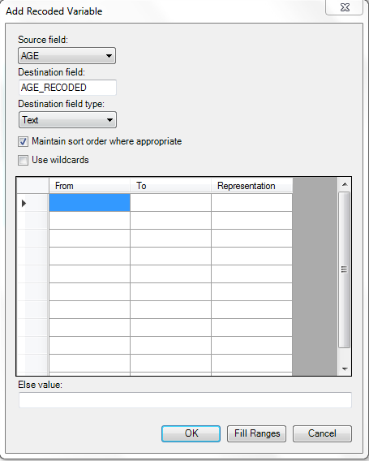
Add Recoded Variable dialog box
Group Age values in categories continued:
- Select Age from the Source field drop-down list,
- You can modify the name of the new variable, if desired, in the Destination field box. Otherwise, the variable name assigned will be based on the Source field name followed by the suffix _RECODED format (i.e. AGE_RECODED).
- Click the Fill Ranges button. The Fill Ranges dialog box displays.
- Enter 0 for Start value, 65 for End value, and 10 for By. Click OK.
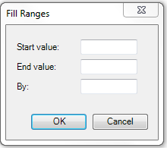
Add Recoded Variable/Fill Ranges
The Add Recoded Variable dialog box displays with the From, To, and Representation columns. Click OK and the recoded variables and conditions show in the Variable Definitions text box.

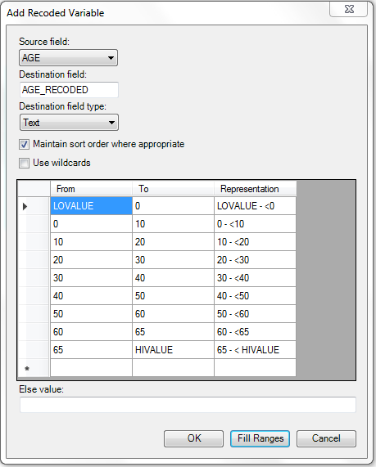
Add recoded variable ranges
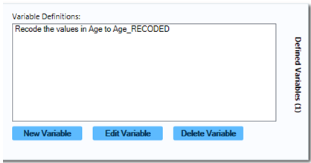
Variable Definitions dialog box
View the new frequency of Age_RECODED values by right-clicking on the canvas. Next, go to Add Analysis Gadget > Frequency. Select Age_RECODED from the Frequency of list and click OK.
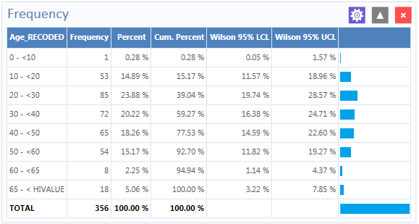
Age_Recoded Frequency list
The Age_Recoded variable contains eight distinct values, making analysis easier than the original data set.

With Simple Assignment
Simple Assignment assigns values from existing variables to newly defined variables.
Simple Assignment steps Part 1:
- Set the Data Source to the Sample.prj project located in the Epi Info 7\Projects\Sample folder.
- Select Surveillance from the Data Source Explorer menu and click OK.
- Move the mouse cursor over from the left-hand side of the Visual Dashboard canvas, hovering over the Defined Variables gadget. Also, you can click the variables icon in the top left. The gadget fully expands.
- Click the New Variable button.
- Select With Simple Assignment. The Simple Assignment dialog box displays.
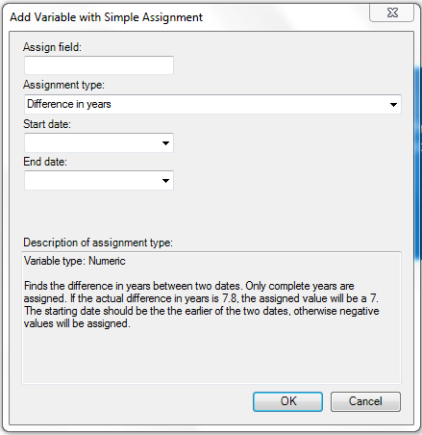
Add Variable with the Simple Assignment
Simple Assignment steps part 2:
- Enter Age_New, in the Assign field.
- Select Difference in years from the Assignment type drop-down list.
- Select BirthDate from the Start Date drop-down list.
- Select SYSTEMDATE from the End Date drop-down list. The system date is a system-level variable representing the current date and time on a host computer.
- Click OK. A description of the assignment displays in the Variable Definitions text box within the Defined Variables gadget.
You can see the Age_New variable in line list view. Go ahead and right-click on the canvas and then select Add Analysis Gadget > Line List. Select Age_New from List of Variables to display and click OK.
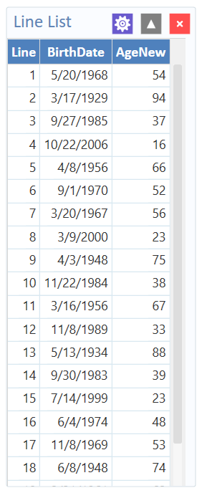
Simple Assignment Line List
The example shows the current age. The age is the difference between the patient birth date and the current date (on the host computer). Analysis Gadget > Line List view displays the new variable created via Simple Assignment.

With Conditional Assignment
Conditional Assignment defines one or more criterion for a new variable. Execution of the Conditional Assignment occurs if the criteria is true. Alternative assignments occur after the Else statement. The Else statement executes when conditions are not true. When a condition is not true, and the Else statement has not been selected, no assignments are added.
To add a new variable with a Conditional Assignment, move the cursor over the Defined Variables gadget on the left-hand side of the Visual Dashboard canvas. Also, try clicking the Variables icon on the top left of the canvass. The gadget fully expands. Click the New Variable button and select With Conditional Assignment.
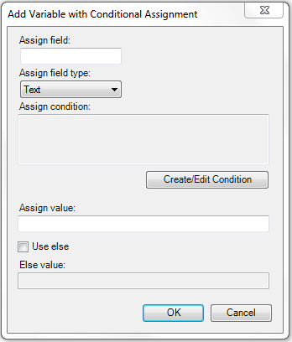
Add New Variable with Conditional Assignment
Field descriptions of the Add New Variable with Conditional Assignment box are listed below:
- Assign Field – add the new variable name.
- Assign Field Type – shows the format of the new variable. The options are Text, Numeric, or Yes/No.
- Create/Edit Condition – allows the creation of criteria to be executed. Applies assigned values when specified conditions for the text box are true.
- Assign Value – states the value of a new variable when the Assign Condition is true.
- Use Else – checkbox shows a specified Else Value. This checkbox is unmarked by default.
- Else Value – occurs when the statement in the Assign Condition text box is false.
View the following example. if the Age variable has a value between 17 and 30, YoungAdult is assigned the Yes variable. The No variable is assigned when the Age value falls outside of this range.
Conditional Assignment Part 1:
- Set the Data Source to the Sample.prj project located in the Epi Info 7\Projects\Sample folder.
- Select Surveillance from the Data Source Explorer menu and click OK.
- Move the mouse cursor over the Defined Variables gadget. Find it on the left-hand side of the Visual Dashboard canvas. You can expand the gadget for full visibility.
- Click the New Variable button.
- Select With Conditional Assignment. The Add Variable with Conditional Assignment dialog box displays.
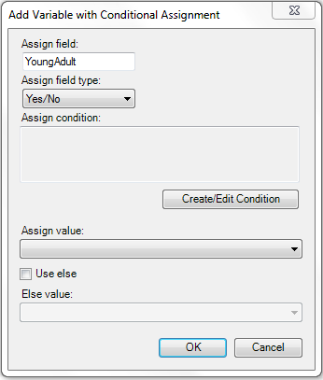
Conditional Assignment / Create Edit Condition

- Enter YoungAdult, in the Assign field.
- Select Yes/No from the Assign field type drop-down list.
- Click on the Create/Edit Condition button. The Specify Assign Condition dialog box displays.
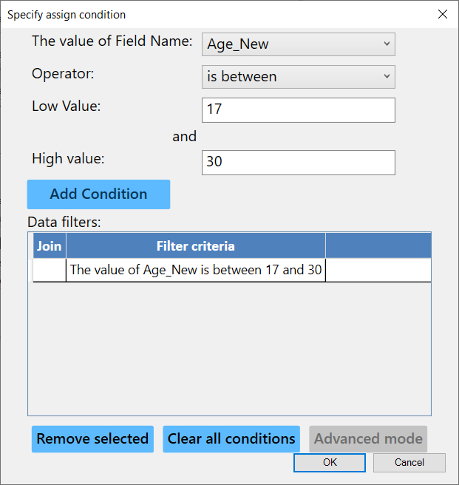
Add Condition dialog box
Conditional Assignment Part 2:
- Select Age_New from the Field Name drop-down list.
- Select is between from the Operator drop-down list.
- Enter 17 for the Low Value: parameter.
- Enter 30 for the High value: parameter
- Click Add Condition.
- Click OK. The filter criteria appear in the Data Filters list.
- Click OK in the Specify Assign Condition dialog box.
The condition now displays in the Assign Condition text box within the Add Variable with Conditional Assignment dialog box.
- Select Yes from the Assign Value drop-down list.
- Check the Use Else checkbox.
- Select No from the Else Value drop-down list and click OK.
A description of the assignment displays in the Variable Definitions text box within the Defined Variables gadget.
You can see the YoungAdult variable in line list view. Right-click on the canvas and then select Add Analysis Gadget > Line List. Select YoungAdult and AgeNew from List of Variables to Display and click OK. Check marks highlight lines for which the conditional assignment is true.
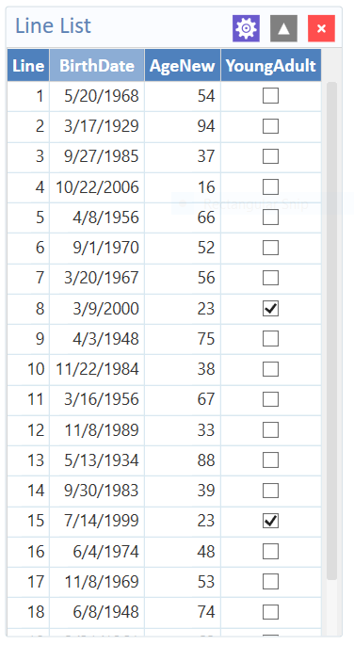
YoungAdult Conditional Assignment Line List
Note: The Else clause, found at the end of IF statements, specifies actions for unmet conditions. Without the Else clause, YoungAdult would be null or missing for any values falling outside the 17 to 30 range.

With Formatted Value
You can change the format and name of existing variables with the Formatted Value option. The option is effective with date fields. View the example below.
- Set the Data Source to the Sample.prj project.
- Select Surveillance from the Data Source Explorer menu and click OK.
- Move the mouse cursor over the Defined Variables gadget. You can also click the Variables icon in the top left of the screen. The gadget expands to full visibility. Click the New Variable button.
- Select With Formatted Value. The Add Formatted Value dialog box displays.
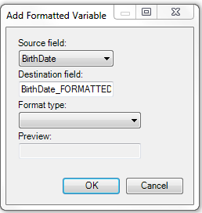
Add Formatted Variable dialog box

- Select BirthDate from the Source field drop-down list.
The Destination field automatically shows the source field with a suffix of “FORMATTED” (i.e., Birthdate FORMATTED). You can change the name of the Destination field.
- Select the long date from the Format type drop-down list. Using the current system date, a sample long date value displays in the Preview field. Click OK.
A description of the assignment displays in the Variable Definitions text box within the Defined Variables gadget.
- Right-click on the canvas and select, Add Analysis Gadget > Line List. Now you can see the BirthDate_FORMATTED variable in line list view. Select BirthDate_FORMATTED from List of Variables and then click OK.
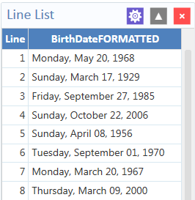
Formatted Variable line list
The Analysis Gadget > Line List displays the new variable created in Formatted Variable.

With Assigned Expression
Assigns the result of an expression. Also, it assigns a variable field value, as shown in the example below. In the example, the zip code field is a number. Use the zip code in a map. Define a new zip code variable and assign text values.
Steps:
- Set the Data Source to the Sample.prj project.
- Select Surveillance from the Data Source Explorer menu and click OK.
Move the mouse cursor over the Defined Variables gadget on the left-hand side of the Visual Dashboard canvas. Also, you can click the Variables icon at the top left of the screen. The gadget fully expands.
- Click the New Variable button and select Assigned Expression. The Add Variable with Expression dialog box displays.
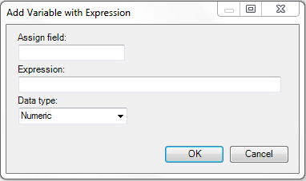
Add Variable with Expression

- In the Assign Field, enter Zip2.
- Type the syntax: <ZipCode + ‘-0000’> in the Expression field.
- Select Text from the Data type drop-down list and click OK.
The assignment displays in the Variable Definition text box within the Defined Variables gadget. Right-click on the canvas and then select Add Analysis Gadget > Line List. Now you can see the Zip2 variable in line list view.
- Select Zip2 from List of Variables to display. Then click Generate Line List.
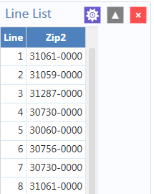
Add Variable with Expression Line List

Creating a Variable Group
The Create Variable Group option in Visual Dashboard allows for the temporary grouping of variables. This option is useful when there are multiple variables of the same format and analyzing each is impractical. Use Group variables with Combined Frequency and MxN/2×2 gadgets. The following example shows how to create a variable group.
- Set the Data Source to the Sample.prj project.
- Select Oswego from the Data Source Explorer menu Click OK.
- Move the mouse cursor over the Defined Variables gadget on the left-hand side of the canvas. You can also click the Variable icon in the top left of the screen. The gadget fully expands.
- Click the New Variable button.
- Select Create Variable Group. The Create Group dialog box displays.
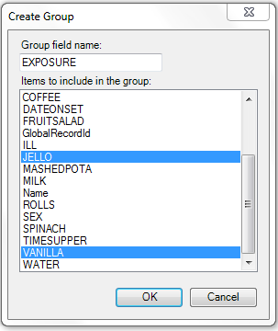
Create Group variable options
- Enter “Exposure” in the Group field name and select JELLO and VANILLA from the choices for the group list. Hold down the Ctrl key on your keyboard to select more than one variable at a time. Click OK.
- The Defined Variables gadget displays the variable group statement in the Variable Definitions text box.

Edit Variable
The Edit Variable option allows an existing variable definition to be changed. The following example will add a new variable to an existing Exposure group variable such as the one created in the section Creating a Variable Group.
- Move the mouse cursor over the Defined Variables gadget on the left-hand side of the Visual Dashboard canvas. Also, you can click the Variables icon in the top left of the screen. The gadget expands to full visibility.
- Click the Edit Variable button.
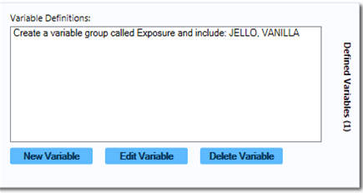
Variable group defined
- The Create Group dialog box displays, with JELLO and VANILLA highlighted.
- Press and hold the Ctrl key on your keyboard and select SPINACH to add it to the variable. Click OK.
The Exposure group variable now includes Spinach. It displays in the Variable Definitions text box within the Defined Variables gadget.

Delete Variable
The Delete Variable option in the Defined Variables gadget removes a defined variable from the system. In this example, the Exposure group variable will be deleted.
- Move the mouse cursor over the Defined Variables gadget or click the Variables icon at the top left of the screen. The gadget expands and becomes fully visible.
- Click on the Exposure variable definition within the textbox.
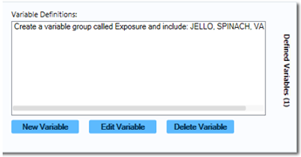
Variable Definitions box
- Click on the Delete Variable button.
The variable is deleted from the Variable Definitions text box.

Adding and Removing Data Filters

Add a Filter
Visual Dashboard typically loads all records in a file. The Data Filters gadget in Visual Dashboard allows you to select a subset of data by specifying certain conditions. This is useful when trying to analyze a specific group of records. There are two modes in this gadget: guided and advanced. The Guided Mode allows you to apply conditions by selecting values from Field Name, Operator, and Value drop-down lists. Filters may be applied in the Advanced mode by entering the filtering conditions in the free form text box. Follow the steps below and add a filter in Guided Mode. Advanced mode is discussed in a later section.
- Select the EColi.prj data source.
- Click FoodHistory from the Data Source Explorer menu. Click OK.
- Move the mouse over the Data Filter gadget from the right-hand side of the Visual Dashboard canvas. You can also click the Filters gadget (funnel) icon in the top left of the screen. The gadget expands to full visibility.
- Select ILL from the Field Name drop-down list.
- Select equal to from the Operator drop-down list.
- Select Yes from the Value drop-down list.
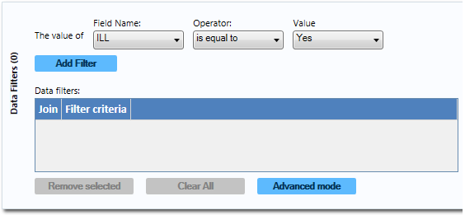
Data Filter Gadget/Add Filter
Now you can filter record results with the Data Filter gadget.
- Click the Add Filter button. The filter condition is added to the Data filters grid within the gadget. View the screenshot of the Data Filter gadget.
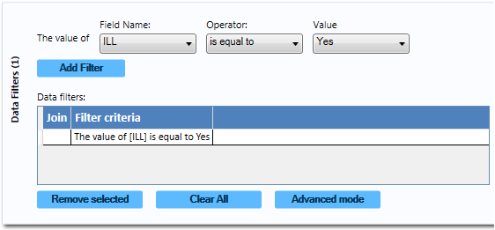
Data Filter Gadget/Add Filter with Condition
All gadgets on the canvas refresh when adding or removing a filter condition. The record count now reads 276, showing that there are 276 out of 359 records in which “The value of [ILL] is Yes.”
Add another filter:
Move the mouse over the Data Filter gadget, from the right-hand side of the canvas. You can also click the Filters gadget at the top left corner. The gadget fully expands.
- Select Age from the Field Name drop-down list.
- Select is between from the Operation drop-down list.
- Type 20 for the first box of the two Value text boxes.
- Type 29 for the second box from the Value text boxes.
- Click Add Filter. A context menu displays asking if you want to add this condition using an AND or OR operator. Choose the appropriate operator.
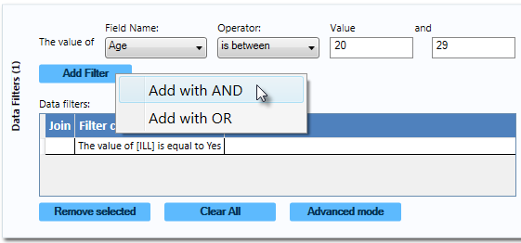
Adding a second condition
The filter condition is added to the Data filters grid. You can find it beneath the first condition.
The record count shows 64 records. This shows only 64 records match two established filter criteria.
- Criteria 1: the patient was ill.
- Criteria 2: The patient is between 20 and 29 years of age.
All gadgets added to the canvas will only display data from these 64 records. The filter settings appear at the top of the canvas.
Data Filter setting

Remove Selected Filter
Follow the steps below to remove individual filters. Move the mouse over the Data Filter gadget, on the right-hand side of the Visual Dashboard canvas. You can also click the Filters gadget at the top left corner. The gadget expands to full visibility.
- Remove the second condition, “The value of Age is between 20 and 29.”
Click on it to select it from the list.
- Click the Remove Selected button. The condition displays.
- Select the remaining condition.
- Click the Remove Selected button. The condition displays, leaving any additional conditions. The system returns to the full dataset when all filters are removed.

Clear All Filters
The Clear All button removes all existing filters. Use this quick and easy step rather than removing each filter.
- Move the mouse over the Data Filter gadget or click the Filters gadget in the top left corner of the right-hand side of the Visual Dashboard canvas. The gadget expands to full visibility.
- Click the Clear All button. All existing filter conditions disappear.
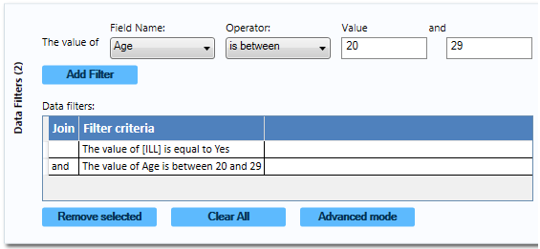
Filter with Two Conditions

Advanced Filter Mode
Type the desired data filter string into the text box using Advanced Filter Mode. Apply the filter and the canvas shows records that meet specified conditions.

Note: Advanced mode uses the. NET DataView.RowFilter syntax. For more Information, refer to Microsoft’s website for DataView.RowFilter Property. https://docs.microsoft.com/en-us/dotnet/api/system.data.dataview.rowfilter?view=net-5.0
The following example demonstrates how to use advanced filters.
- Move the mouse over the Data Filter gadget or click the Filters gadget in the top left corner of the right-hand side of the Visual Dashboard canvas. The gadget expands to full visibility.
- Select Advanced Mode. The Advanced mode dialog box displays.
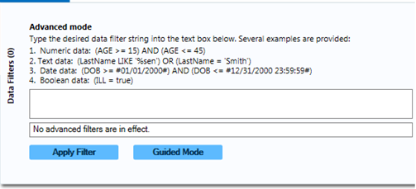
Advanced Mode
In the text box, enter the following condition (([ILL] = 1) and (Age >= 20 and Age <= 29)) AND RECSTATUS > 0 (do not include the quotation marks).
- Click the Apply Filter button.
Instead of “No advanced filters are in effect,” you will see, “The filter is valid and is now in effect.” Apply filters and conditions displays in green font.
The record count in the top right corner of the Visual Dashboard canvas reads 64, showing that there are 64 out of 359 records where the value of ILL is Yes and the value for AGE is between 20 and 29.
Note: You can toggle between the Guided Mode and the Advanced Mode by clicking on the respective button on each screen.

Displaying Statistics and Records
Analysis is carried out in the Dashboard using Gadgets. Gadgets are moveable screen elements that perform specific statistical functions. For example, there is a Logistic Regression gadget that can carry out conditional and unconditional logistic regression. Shown below is an example of a frequency gadget. Multiple gadgets can be incorporated in the Visual Dashboard.
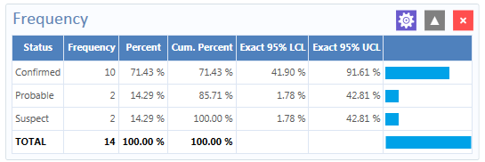
Frequency gadget output

Summary of Analysis Gadgets

Epi Info™ 7 Visual Dashboard includes a collection of analysis gadgets designed to view, interpret, and display data on the canvas. Customize your gadgets to highlight important data. Arrange and resize any combination of gadgets so you can correlate information and draw conclusions. View the list of Analysis Gadgets below.

- Line List – View data in tabular format.
- Frequency – Shows number of records with field values.
- Word Cloud – Displays the most common words used in a font size proportional to word frequency.
- Combined Frequency – Displays frequency and percentage of grouped variables.
- M x N / 2 x 2 Table – Examine relationships between two or more categorical values.
- Matched Pair Case -Control – Compares an exposure variable, outcome variable like case vs. control. Match variables, linking each case to its control.
- Means – Calculates the average for a continuous numeric variable.
- Duplicates List – Identify potentially duplicate records.

Charts – Produces histograms, scatter plots, pie charts, and bar and line graphs directly from data files.
  - Column Chart
  - Line Chart
  - Area Chart+
  - Pie Chart
  - Aberration Detection Chart
  - Pareto Chart
  - Scatter Chart
  - Epi Curve Chart

Advanced Statistics – provides options to determine the relationship between one dependent variable with one or more independent variables; one or more explanatory variables; or analyze data collected using simple random sampling or unbiased systematic sampling, and/or through more complex sampling strategies such as stratification, cluster sampling, and the use of unequal sampling fractions.
  - Linear Regression
  - Logistic Regression
  - Complex Sample Frequencies
  - Complex Sample Means
  - Complex Sample Tables

Line List Introduction
The Line List option creates a list of the current dataset, so you can view details in your current data source. You can display, sort and group selected variables. Line List supports adding groups or pages. Select this option from the bottom of the Variables to display in the Line List Variables property panel, below the Fields list.
- Select the EColi.prj data source. Open the FoodHistory form from the Data Source Explorer menu.
- Right-click on the canvas and select Add Analysis Gadget > Line list. The Line List gadget configuration window opens to the Variables property panel.
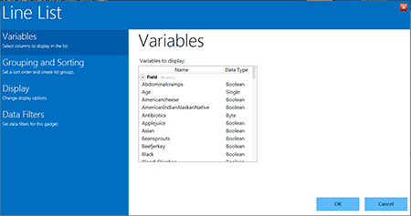
Line List gadget with options
- Select multiple variables from Variables to display. Hold down the Ctrl key and click on the variables you want to display. Use Ctrl + A to select all variables at once.
- Click OK. The line list appears on the canvas. The graphic below shows the list with all variables selected.
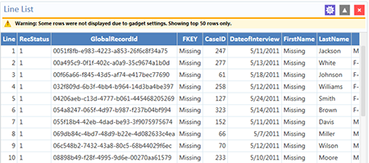
Generated Line List of all variables
Note: View the yellow warning at the top of the output. By default, the line list will only show the top 50 rows. The row limit exists to improve performance when working with large datasets. The Max Rows to Display setting can be modified in the Display property panel, which is explained later.

Sorting Records
Arrange file records in a particular order, such as alphabetically by name, or by age. Sort records by clicking on the column name in the line list. You can also go to the Sorting and Grouping property panel. Use Sort options in the Line List configuration window.

Sorting a List by Column Name
Follow the steps below to sort the list by Age.
- Select the EColi.prj Data Source. Open the FoodHistory form from the Data Source Explorer menu.
- Right-click on the canvas and select Add Analysis Gadget > Line list. The Line List gadget configuration window opens to the Variables property panel.
- Select all variables from the List Variables to Display box by pressing Ctrl + A on your keyboard. Click OK. The Line List results appear on the Visual Dashboard canvas.
- Click on the Age column heading (you may have to scroll over to see the Age column). The records are displayed by Age in ascending order. The Age column header also turns red to show records will sort by the Age variable.
- Click the Age column header again to sort in descending order. The Age column header turns green to show it is sorted in descending order.

Sorting a List Using Line List Grouping and Sorting Properties
- Select the EColi.prj Data Source. Open the FoodHistory form from the Data Source Explorer menu.
- Right-click on the canvas and select Add Analysis Gadget > Line list. The Line List gadget configuration window opens to the Variables property panel.
- Select all variables from List Variables to Display, by pressing Ctrl + A on your keyboard and Click OK. The Line List results appear on the Visual Dashboard canvas.
- Click on the gadget gear icon at the top of Line List to sort variables.
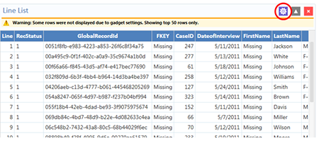
Line List with Gadget Configuration Icon Noted
- Select Grouping and Sorting in the configuration window and then select Sorting Method of Ascending or Descending.
The following steps require a mouse double-click action.
Double-click:
- a variable from the Available Variables list.
- on each variable will arrange multiple variables.
- the selected variable movies it to the Sort Order box.
- on a variable in the Sort Order box to remove the variable from the list. If you want to group the list by a particular field, select the field from the Group By drop-down list. Click OK.
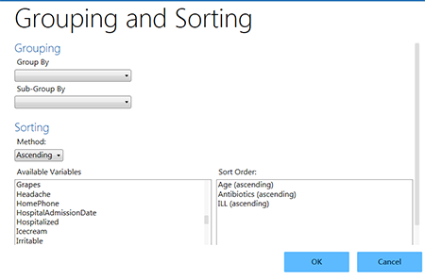
Line List Grouping and Sorting
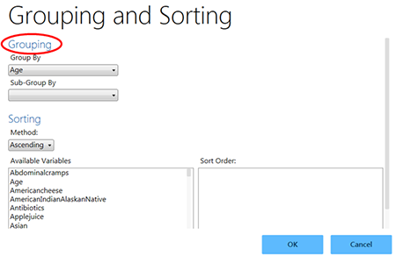
Line List/Grouping options
Visual Dashboard generates and displays a separate line list, grouped by the variable you select. You can hide a list from view by clicking on the arrow to the left of the list heading.
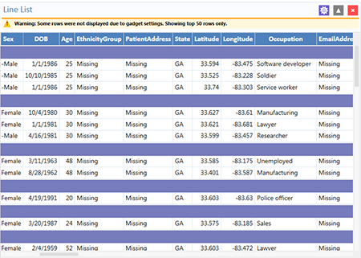
Line List with Grouping results
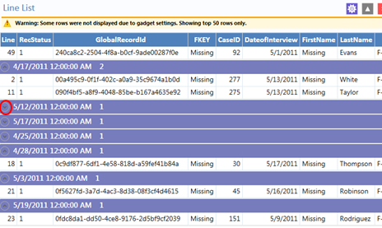
Line List hidden view, with circle indicating “hide” arrow

Remove Sort Criteria
Remove sort criteria by following the steps below.
- Right-click on the Line List.
- Select Remove All Sort Criteria.
The Line List will appear with the sort criteria removed.

Other Line List Properties
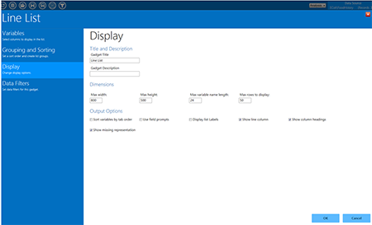
Line List Display options
Other options for the Line List gadget are available by selecting Display in the configuration window.
- Max width — indicates the maximum Line List display width in pixels.
- Max height — indicates the maximum Line List display height in pixels.
- Max variable name length — text box allows for the truncation of long column names in the list output. It is set to 24 by default.
- Max rows to display — text box allows the user to change the maximum number of rows that the Line List gadget displays. It is set to 50 by default. Display up to 2,000 rows.
Output Options (Located at the bottom of the Display screen)
- Sort variables by tab order — The checkbox forces the columns in the output to be sorted by their tab order. It is not checked by default.
- Use field prompts — The checkbox uses the field prompt as the column heading, rather than the field name. It is not checked by default.
- Display list labels — The checkbox uses the label value for option fields and comment legal fields rather than the value stored in the database.
Note: These first three output options are available only when the Data Source is an Epi Info™ 7 project. If the Data Source is from something else like an Excel spreadsheet, these options have no effect.
- Show line column — option that adds the Line column to the list and displays the line number when the checkbox is selected.
- Show column headings — option that shows the line list column headings when the checkbox is selected.
- Show missing representation — option that shows the word or symbol that represents a missing value for any field that does not have a value. By default, the word “Missing” is used, but other options include “Unknown”, “(.)” or another custom setting as specified in the Tools > Options > Analysis tab. If the checkbox is not selected, an empty field shows a blank space.

Exporting a Line List
Once the Line List is created, the following export options are available: Copy List Data to Clipboard, Send List Data to Web Browser, and Send List Data to Excel.
The next three steps explain how to copy the list data to the clipboard.
- Right-click on the Line List.
- Select Copy List Data to Clipboard.
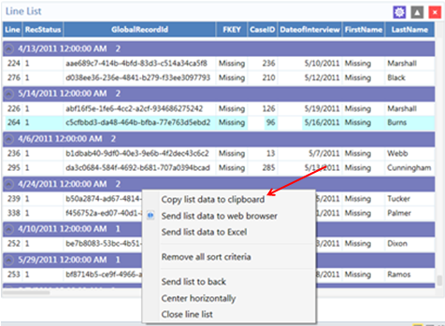
Copy list data to clipboard
The data is now on the clipboard and may be exported.
The next three steps explain how to Send List Data to Web Browser.
- Right-click on the Line List.
- Select Send List Data to Web Browser.

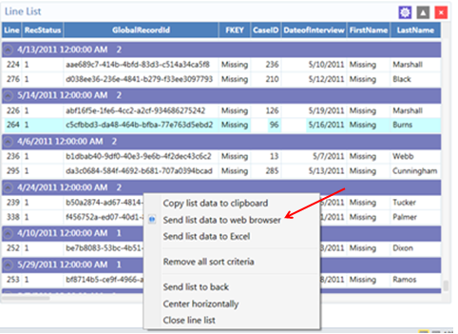
Send list data to web browser
The data appears in your default web browser.
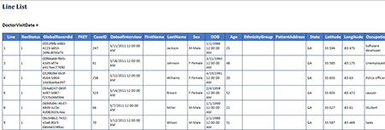
List data in web browser
The next three steps explain how to send list data to Microsoft Excel.
- Right-click on the Line List.
- Select Send List Data to Excel.
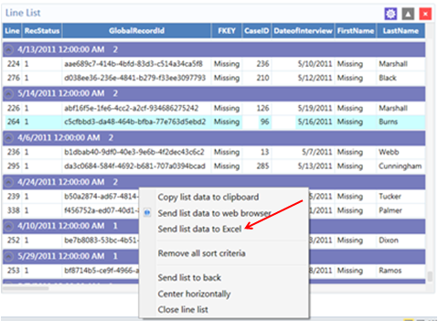
Send list data to Excel
The list data appear in a Microsoft Excel spreadsheet.
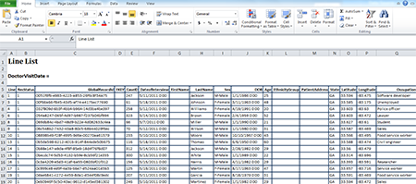
List data in Excel
Note: Use this feature with Microsoft Excel only.

Frequency
The Frequency gadget counts each occurrence of a value for a specified variable and gives the absolute and relative frequencies for each value. The resulting output is a frequency table showing how many records have values for each variable, the percentage of the total, a cumulative percentage, and upper and lower confidence intervals.
- Select the EColi.prj Data Source. Open the FoodHistory form from the Data Source Explorer menu.
- Right-click on the canvas and select Add Analysis Gadget > Frequency. The Frequency gadget configuration window opens to the Variables property panel.
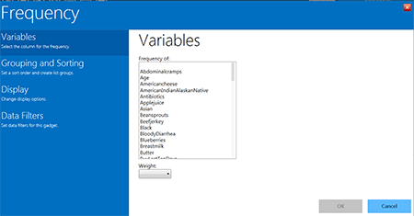
Frequency gadget
- Select a variable from the data table in the Frequency of list. For this example, select sex as the desired variable.
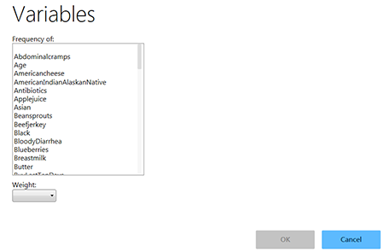
Selecting frequency of variable
- Click OK. The results appear on the Visual Dashboard canvas.
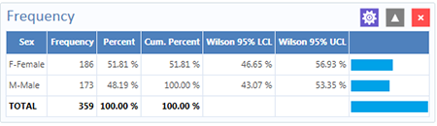
Frequency results
The Frequency column counts individuals that are either female or male. The Percent column shows the percentage of female or male. The Wilson 95% LCL (Lower Confidence Limits) are a range of values that indicates the likely location of the true value of a measure, meaning (in this instance) that the percentage of females is likely to be between 46.64% and 56.93%.

Frequency Additional Options
Additional options are available in the Frequency gadget:
- Select the EColi.prj Data Source. Open the FoodHistory form from the Data Source Explorer menu.
- Right-click on the canvas and select Add Analysis Gadget > Frequency. The Frequency gadget configuration window opens to the Variables property panel.
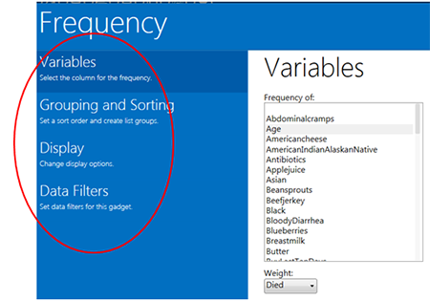
Frequency gadget functions menu
These options are available in the Frequency gadget, under the various functions located in the left-hand column:
  - Weight (available under Variables) – field for the weight variable. (e.g., aggregate data analysis.)
  - Stratify By (available under Grouping and Sorting) – Use this field for stratifying (grouping) the output.
  - Sort high to low (available under Grouping and Sorting) – Displays the results sorted from high to low based on the selected frequency of variables.
  - Display all list values (available under Display) – Applies when the frequency variable is a drop-down list field in an Epi Info™ 7 project. When selected, the output will show all the drop-down list values even if they have a count of zero.
  - Display list labels (available under Display) – Applies when the frequency variable is a Comment Legal field or Option Field in an Epi Info™ 7 project. When selected, the output will show the value and label for Comment Legal fields and the option button label for Option fields.
  - Include Missing Values (available under Display) – Displays the count of rows having missing values. By default, it is unchecked.

- Select Age from the data table, from the Frequency of list in Variables.
- Select Died from the data table, from the Weight drop-down list below.
- Select Hospitalized from the Stratify by list.
- Click OK. Results appear on the canvas.
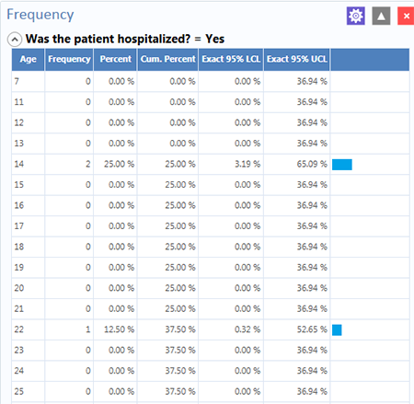
Frequency line list with variables

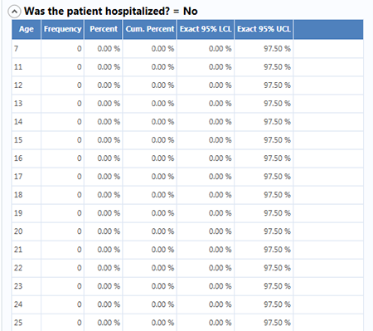
Frequency Line List stratified view #2
The results show the frequency of deceased patients by age and are stratified by whether the patient was hospitalized or not. The results will display the age, frequency, percent, cumulative percent and upper and lower 95% confidence intervals. The last column is the percent bar.
You can also open the Display property panel. It shows additional properties for the Frequency gadget. The following options are available in Display:
- Gadget Title – Enter a title for the current gadget. This title will appear at the top of the gadget results on the canvas.
- Gadget Description – Enter a description for the current gadget. This description will appear at the top of the gadget results on the canvas, just below the title.
- Use field prompts – Use the field question or prompt instead of the field name. This property is checked by default.
- Draw borders – Use this setting for drawing frequency border.
- Draw header row – Control the appearance of frequency headers.
- Draw total row – Manipulate the frequency totals.
- Decimals to display – Set the number of decimals that will be displayed in the results. The possible values range from zero to four. This is set to two by default.
- Maximum rows to display – Choose the number of rows to display.
- Max width of percent bar – Select the width for the percent bar column using a % value.

Word Cloud
The Word Cloud gadget shows a visual snapshot of frequently used terms in the current data set. Word Cloud returns a graphic of words and terms, with font sizes illustrating the number of times a word or term appears, in comparison to others. This gadget is most valuable for analyzing text fields and multi-line text fields. For example, it can condense a field with patient complaints from verbose to commonly used words. Word Cloud can also analyze other text-based fields such as Legal Value, Comment Legal, and Codes fields.
The gadget allows you to exclude frequent mundane words from the search with an editable list of default words for Epi Info™ to ignore such as: a, am, an, and, are, as, at, but, by, for, her, his, I, if, in, is, it, me, my, not, of, on, or, our, pm, that, their, this, to, us, was, we, were, will, with, would, you, and, your, from the analysis.
- Select the Sample.prj Data Source. Open the Surveillance form from the Data Source Explorer menu.
- Right-click on the canvas and select Add Analysis Gadget > Word Cloud. The Word Cloud gadget configuration window opens to the Variables property panel.
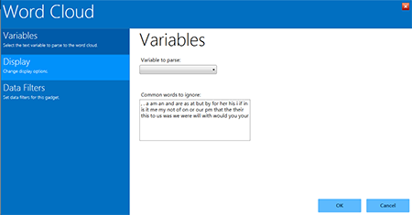
Word Cloud gadget
- Choose the desired variable on which to parse words from the drop-down list. For this example, select Race. Common words to ignore remain as listed in the default.
- Click OK. The results appear on the Visual Dashboard canvas. The font size for each word in the selected variable group denotes the use of that word relative to others in the group. In this example, the most common color in the selection is “White,” followed by “Blue.”

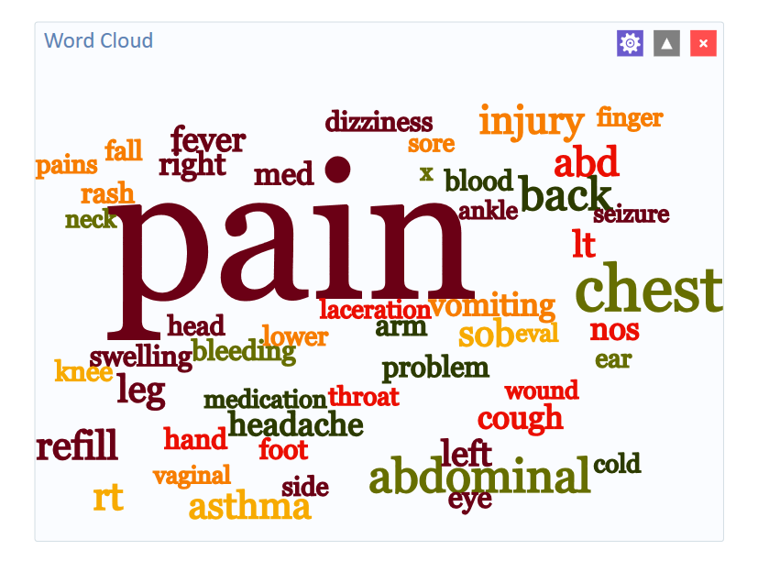
Word Cloud results

Combined Frequency
The Combined Frequency gadget creates a table that shows the frequency and percentage of affirmative responses to the check box and Yes-No fields contained within a group field (i.e., checked boxes are affirmative, as are “Yes” answers to Yes-No fields). All other field types are ignored. In the following example, the Demographic Information group contains several check box fields for race, and it allows you to “Check all that apply.”
- Select the EColi.prj Data Source. Open the FoodHistory form from the Data Source Explorer menu.
- Right-click on the canvas and select Add Analysis Gadget > Combined Frequency. The Combined Frequency gadget configuration window opens to the Variables property panel. The Variables to display list only shows Group variables.
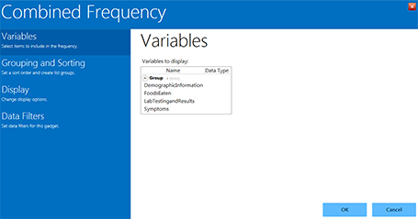
Combined Frequency gadget
- Select Symptoms from the Variables to Display list under Group,
- Click OK. The results appear on the Visual Dashboard canvas.
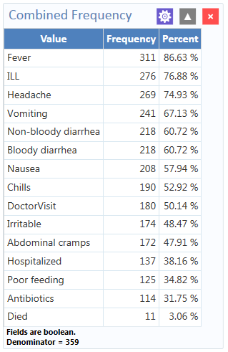
Combined Frequency results

Combined Frequency Advanced Options
Using the Combined Frequency advanced options:
- Select the EColi.prj Data Source. Open the FoodHistory form from the Data Source Explorer menu.
- Right-click on the canvas and select Add Analysis Gadget > Combined Frequency. The Combined Frequency gadget configuration window opens to the Variables property panel.
- Select DemographicInformation in the Variables options from the Group field.
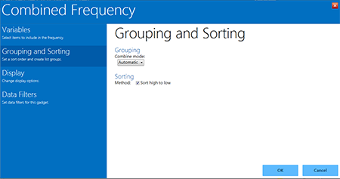
Combined Frequency Grouping and Sorting options
- Click Grouping and Sorting and select Automatic from the Combine Mode drop-down list. Here are the functions of each option in that drop-down:
  - Boolean — use this mode for Yes/No and Checkbox fields, or if you wish for the fields in the group to be treated as such.
    - Value to treat as true – This field appears when the Combine Mode is Boolean. The specified value is treated as the true or positive value and all other values are treated as false or negative values.
  - Categorical — use this mode if your data is grouped according to similar characteristics in a way that shows the relative frequencies of each group or category.
  - Automatic — will automatically determine the appropriate combination mode of either Boolean or Categorical.
The Sort High to Low checkbox is checked by default. This option displays the results sorted from highest group field frequency to the lowest.
- Click Display and mark your selection for Show Denominator. This option will display the total number of records in the results. The box is checked by default.
- Click OK. The Combined Frequency results appear on the Visual Dashboard canvas.
Combined Frequency results with advanced options
The result displays the frequency and percentage of each symptom selected check box and each Yes-No field with a value of “Yes”. Note the denominator included at the bottom of the results window.

M x M/ 2 x 2 Table
Epidemiologists frequently use 2 x 2 tables to examine the relationship between two or more categorical values. In these tables, an exposure variable is usually considered as the risk factor. The outcome variable is considered the disease of consequence (e.g., the person had the disease or outcome of interest, or they did not). Values of the first variable will appear on the left margin of the table, and those of the second will be across the top of the table. Normally, cells contain counts of records matching the values in corresponding marginal labels. The M x N /2 x 2 Table analysis gadget in Visual Dashboard is demonstrated below:
- Select the Sample.prj Data Source. Open the Oswego form from the Data Source Explorer menu. Click OK.
- Right-click on the canvas and select Add Analysis Gadget > M x N /2 x 2 table. The Cross Tabulation Properties gadget configuration window opens to the Variables property panel.
- From the Exposure drop-down list, select VANILLA.
- From the Outcome drop-down list, select ILL.
Other options in the gadget allow you to add a weight variable or stratify the data by another variable. This example does not use these options.

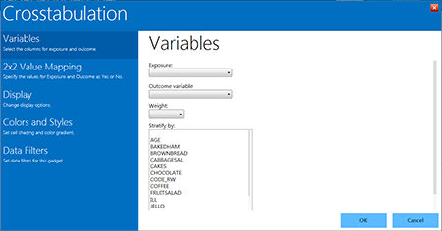
Cross tabulation gadget
- Click OK. Results appear on the Visual Dashboard canvas.
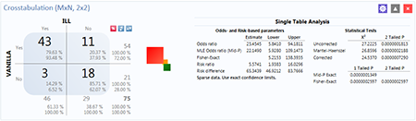
Cross tabulation results
The results display a 2 x 2 table and a single table analysis of all records cross tabulated by exposure to vanilla where the outcome was ill. Out of the 75 records in this data set, 43 patients were exposed to vanilla and became ill. Eleven patients were exposed to vanilla and did not become ill. Of the 21 patients who were not exposed to vanilla, only three became ill.
The Single Table Analysis chart on the right displays Odds Ratios, Risk Ratios, and Statistical Tests results for this example.

Matched Pair Case-Control
The Matched pair case-control is for use with pair-matched case-control studies. Each case must have exactly one matched control. For this reason, it is generally incorrect to perform the analysis using 2×2 tables since it does not take matching into consideration. To use this option, you need to specify an Exposure Variable, the Outcome Variable (i.e., case vs. control), and a Match Variable that links each case to its control. The following example demonstrates a Matched Pair-Case Control analysis.
The dataset below is from a Matched Pair Case-Control study of the consumption of chicken, where the outcome resulted in the patient becoming ill. The primary exposure was the consumption of chicken AnyChkn, the case control is CaCO, and the Pair Group ID is Matched pairs.
- Select the Case Control DatabaseExample.xlsx data source found in the sample project folder. Note that this will require updating the database type to Microsoft Excel 2007 Workbook (.xlsx) before browsing.
- Select Section_1_3 & 8$ form in the Data Source Explorer menu.
- Click OK.
- Select Add Analysis Gadget > Matched pair case-control. The Matched Pair Case-Control Properties gadget appears.

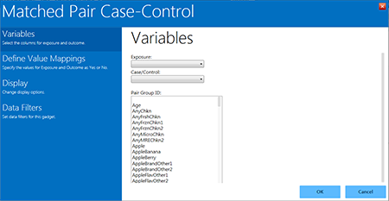
Matched Pair Case-Control gadget
Select:
  - AnyChkn from the Exposure drop-down list.
  - CaCo, from the Case/Control drop-down list,
  - Matched pairs, from the Pair Group ID list.
In the following order, click on:
- Define Value Mappings.
- 1.
- the > button on the Yes values: section.
- 0.
- the > button on the No values: section.
- OK.
The Matched Pair Case-Control results displays on the canvas.
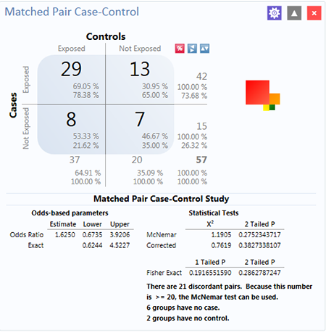
Matched Pair Case-Control results
The results show that out of 57 matched pairs, 29 had both the Case and the Controls exposed to AnyChkn, 13 had the Case but not the Controls exposed, eight pairs had the Controls exposed but the Case unexposed, and seven had neither the Case nor the Controls exposed.
The Odds-Ratio is greater than 1, which suggests that eating chicken may more likely result in illness. However, the confidence intervals contain 1 and the P values are less than 0.05, indicating that there is no significant association between eating chicken and becoming ill.

Means
The Means gadget calculates the average for a continuous numeric variable. A Yes/No field returns numeric values (Yes=1, No=0), which allows the Means gadget to calculate the proportion of respondents answering yes. For this situation, Analysis Gadget > Means, has two formats:
- If only one variable is selected, the program produces a table like one produced by the Frequency option with descriptive statistics.
- If two variables are selected, the first variable contains the data to be analyzed and the second indicates how groups will be distinguished. The output of this format is a table like one produced by the M x N/ 2 x 2 table with descriptive statistics.
- Select the Sample.prj Data Source. Open the Oswego form from the Data Source Explorer menu.
- Click OK.
- Right-click on the canvas and select Add Analysis Gadget > Means. The Means Properties gadget configuration window opens to the Variables property panel.
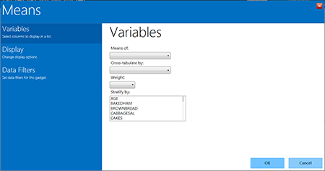
Means gadget
From the Means Of drop-down list, select Age.
- Other choices that can be used in the Variables option include:
  - The Cross-tabulate by drop-down list contains a variable to help determine if the means of a group are equal.
  - The Weight drop-down list contains a variable for weighted analysis.
  - The Stratify by list contains a variable to act as a grouping variable.
Note: These options are not used in this example.
- Click OK. The results are displayed on the canvas.
Additional choices for the means gadget are available in the Display option and include:
- Output columns to display – specifies the columns to include in the current analysis.
- Decimals to display – specifies the number of decimals in the results (possible values range from 0–4 and are set to 2 by default). This option does not apply to the descriptive statistics produced when using a cross-tabulate variable. The descriptive statistics always show 4 decimal places.
- The Display ANOVA statistics checkbox specifies whether to display the analysis of variance statistics, set by default. If you are working with large data sets without ANOVA statistics, you can improve performance by turning off (un-checking) this feature.
The mean age of individuals in the data set is 36.8.

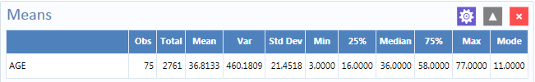
Means Output

Duplicates List
The Duplicates List gadget lists potentially duplicate records. Like a patient registry, everyone must have only one record. The Duplicates List gadget allows you to select a few fields that should be unique and display a few other non-unique fields too. When the gadget runs, it counts the number of occurrences of the key fields for duplicate checking. The gadget displays the message, “No records match the selection criteria” if all rows in the database are unique for the key fields. If any database rows have key fields that match another row, those matching rows are listed in the results.
In the example below, let’s assume a patient registry with a small population, where two individuals sharing the same last name and birthdate is very unlikely. The goal is to check the database to see if there are duplicate records based on the Date of Birth field [DOB] and the Last Name field [LastName]. If we find a match, we might also want to view additional fields, such as CaseID, DateofInterview, and OnsetDate. Then we can make a determination that an individual is actually duplicated in the registry.
Follow these steps:
- Open the EColi.prj project and select the Food History form.
- Right-click on the canvas and select Add Analysis Gadget > Duplicates List. The Duplicates List gadget configuration window opens to the Variables property panel.
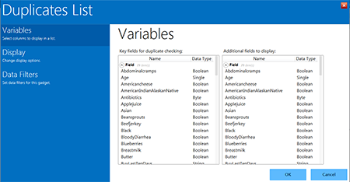
Duplicates list gadget
- Hold down the CTRL key and click on the respective field names.
- Select DOB and LastName in the Key fields for duplicate checking list.
- Select other fields like CaseID, DateofInterview, DoctorVisit, DoctorVisitDate, and OnsetDate, in the Additional fields to display list. This will help you determine if the record is a true duplicate.
- Hold down the CTRL key and click of the field names.
- Click OK.
The system returns any duplicate records in the database. In this example, patients Johnson and Garcia have duplicate records in the database. They were each interviewed on different days and assigned different case IDs.

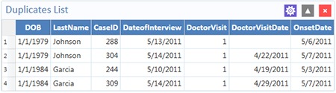
Duplicates list results

Analysis Gadget Charts

- Column Chart
- Line Chart
- Area Chart
- Pie Chart
- Aberration Detection
- Pareto Chart
- Scatter Chart
- Epi Curve

Visual Dashboard produces histograms, scatter plots, pie charts, and bar and line graphs directly from data files. This option produces charts based on the types of data available in the project. The Chart option generates the following chart types:
- Column charts — use vertical bars to represent the count or weight for each value of the main variable(s). Each series results in an additional vertical bar at each point.
- Line charts — connect X and Y data points with straight lines. Each series is represented by a different style of line and both variables must be numeric.
- Area charts — lay series on top of one another for comparison purposes and can be used to illustrate volume as well as counts.
- Pie charts — use a circle to represent each series and each value of the main variable. A slice of the circle is proportional to the value associated with it.
- Aberration detection charts — use line charts to monitor changes in the distribution or frequency of health events when compared to historical data.
- Pareto charts — use vertical bars to represent the count or weight for each value of the main variable(s) and a dashed line to represent the accumulated percentage. Each series results in an additional vertical bar at each point.
- Scatter charts — display variables along an X-Y axis as a scatter plot. The X variable is the independent variable and Y variable is the dependent variable. Each series is represented by a different point style.
- Epi Curve charts — use vertical bars to represent the count or weight for each value of the main variable. Each series creates an additional vertical bar at each point. The main variable must be either numeric or date/time. This graph differs from the bar graph because adjacent bars represent equal ranges of the main variable.
The examples below demonstrate how you can create each chart.

Column Chart
Follow the steps below to create a bar graph using data from the Sample.prj project.
- Open the Sample.prj project and select the Oswego form.
- Right-click on the canvas and select Add Analysis Gadget > Charts > Column chart. The Column Chart gadget configuration window opens to the Variables property panel.
- Select the variable Age from the Main variable drop-down list, to use for the independent variable.
- Maintain the Weight and select the One graph for each value of option at the default setting (none).
- Click OK. The graph appears on the canvas, displaying in columns the number of patients by age.
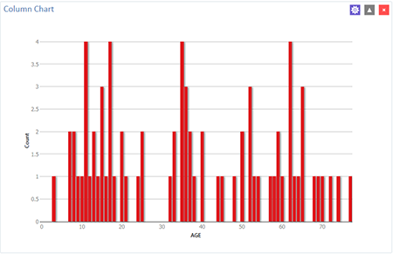
Column chart

Line Chart
Follow the steps below to create a line chart showing counts by date of onset of illness.
- Open the EColi.prj project and select the Food History form.
- Right-click on the canvas and select Add Analysis Gadget > Charts > Line chart. The Line Chart gadget configuration window opens to the Variables property panel.
- Select Onset Date from the Main variables list.
The system returns a line chart of onset dates between April and May from the dataset.
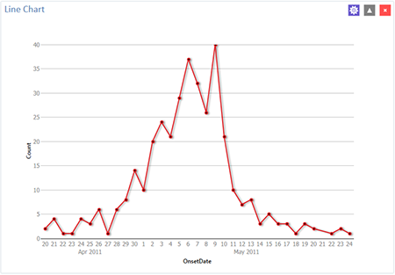
Line chart

Area Chart
Follow the steps below to create an area chart showing fever temperatures of church supper attendees.
- Open the EColi.prj project and select the Food History form.
- Right-click on the canvas and select Add Analysis Gadget > Charts > Area chart. The Area Chart gadget configuration window opens to the Variables property panel.
- Select OnsetDate from the Main variables list.
The system returns a line chart of onset dates between April and May from the dataset.
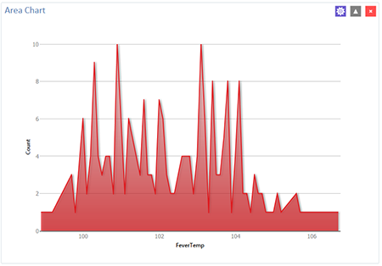
Area chart

Pie Chart
Follow the steps below to create a pie chart showing age groups of church supper attendees. The dataset has individual ages. To create age groups, you can define a new variable with recoded values making age groups from age 0 to age 70 grouped by 10 years per group. Detailed instructions about how to use the Defined Variables gadget are in the Create a New Variable section later in this guide.
- Open the Sample.prj project and select the Oswego form.
Recode the Age variable using the Defined Variables gadget.
  - On the left-hand side of the Visual Dashboard canvas, move the mouse cursor over the Defined Variables gadget. The gadget expands and becomes fully visible.
  - Click the New Variable button.
  - Select With Recoded Value. The Add Recoded Variable dialog box displays.
  - From the Source field drop-down list, select Age. Notice the Destination field is populated with Age_RECODED.
  - Click the Fill Ranges button. The Fill Ranges dialog box appears.
  - Enter 0 for Start value, 70 for End value, and 10 for By.
  - Click OK. The From, To, and Representation columns populate within the Add Recoded Variable window.
  - Click OK. The variables are recoded and are listed in the Defined Variables gadget window.

- Right-click on the canvas and select Add Analysis Gadget > Charts > Pie chart. The Pie Chart gadget configuration window opens to the Variables property panel.
- Select the variable AGE_RECODED from the Main variable drop-down list.
- Maintain the Weight and One graph for each value of, option at the default setting.
- Click OK. The graph appears on the canvas.

The chart shows the age groups of church supper attendees.
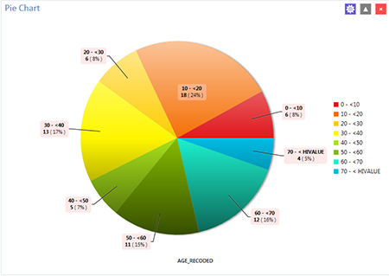
Pie chart

Aberration Detection
The Aberration Detection Analysis gadget can be used with syndromic or national surveillance data. It is designed to monitor changes in the distribution or frequency of health events when compared to historical data. This gadget uses an algorithm implemented by the Early Aberration Reporting System (EARS), which is a tool developed by the CDC Division of Bioterrorism Preparedness and Response. The division assists local-level health offices with early detection of bioterrorism events or possible outbreaks.
The following example shows an Excel spreadsheet named EARS.xls that comes with Epi Info™ 7. Find it in the ProjectsSample project folder.
- Right-click on the canvas and choose Set data source or click the data source icon in the toolbar.
- Click the Database Type drop-down to select Microsoft Excel 97-2003.
- Click Browse and then Browse again to search for the EARS.xls file.
- Browse to the Epi Info™ 7 ProjectsSample folder and select the EARS.xls file.
- Click on Sheet 1$, then click OK.
- Right-click on the canvas and select Add Analysis Gadget. Scroll to highlight Charts, then select Aberration Detection.
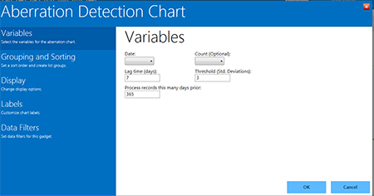
Aberration Detection gadget
The Aberration Detection gadget configuration window opens to the Variables property panel.
Begin by Selecting:
- the DATE variable from the Date drop-down list,
- COUNT, from the Count (Optional) drop-down list.
Maintain the default settings for Lag Time, Threshold, and Process Records This Many Days Prior.

Continue by clicking:
- the Grouping and Sorting option for the property panel.
- the variable SYNDROME, from the Indicators list,
- OK. The Aberration Detection line graph displays on the canvas.
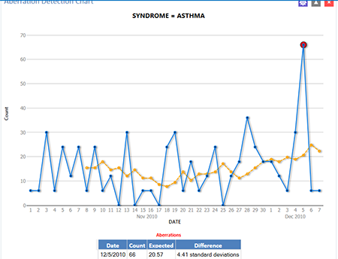
Aberration Detection line graph
The chart and table display aberrations found, date, count, expected count, and the standard deviations. The current number of patient visits with Asthma is higher (Count: 66) than the defined threshold (Expected; 20.57), hence the aberration detected on 12/05/2010. Aberrations may need to be evaluated by an epidemiologist or other public health professional to determine whether they signify an event of public health importance warranting further investigation.

Pareto Chart
Follow the steps below to create a Pareto chart showing age groups of church supper attendees. The dataset has individual ages. To create age groups, you can define a new variable with recoded values making age groups from age 0 to age 70 grouped by 2 years per group. Detailed instructions about how to use the Defined Variables gadget are in the Create a New Variable section later in this guide.
Begin by recoding the age variable. Open the Ecoli.prj project and select the FoodHistory form. You can recode the Age variable using the Defined Variables gadget.
  - Move the mouse cursor over the Defined Variables gadget on the left-hand side of the Visual Dashboard canvas. The gadget expands and becomes fully visible.
  - Click the New Variable button.
  - Select With Recoded Value. The Add Recoded Variable dialog box appears.
  - Select Age from the Source field drop-down list. Notice the Destination field populates with Age_RECODED.
  - Click the Fill Ranges button. The Fill Ranges dialog box appears.
  - Enter 0 for Start value, 70 for End value, and 2 for By.
Click OK. The Add Recoded Variable window appears with the From, To, and Representation columns. Click OK again.
Build your Pareto Chart. Right-click on the canvas and select Add Analysis Gadget > Charts > Pareto chart. The Pareto Chart gadget configuration window opens to the Variables property panel.
- Select the new variable, Age_RECODED, from the Main variable drop-down list.
- Click the Labels option to customize chart labels and axes.
- Update the X-axis angle setting to -90. This step will permit the date values to display fully on the X-axis.
- Click the Display option.
- Change the width setting to 1000. If your computer screen is too small, you might need to change the width setting of the chart to a higher number until the system displays the X-axis labels.
- Click OK. The Pareto chart appears on the canvas.
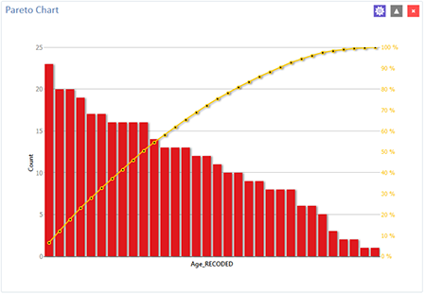
Pareto chart

Scatter Chart
Follow the steps below to create a scatter XY graph using data from the Sample.prj project.
- Open the Sample.prj project and select the EstriolAndBirthweight form.
- Right-click on the canvas and select Add Analysis Gadget > Charts > Scatter chart. The Scatter Chart gadget configuration window opens to the Variables property panel.
- Select the variable Estriol from the Main variable drop-down list. Use it for the independent variable.
- Select the variable Birthweight to use for the independent variable, from the Outcome variable drop-down list,
- Click OK. The graph appears on the canvas, displaying the scatter plot of data points showing the level of Estriol along the X-axis by Birthweight along the Y-axis. A line representing the Linear Regression of the two variables is also included on the chart.

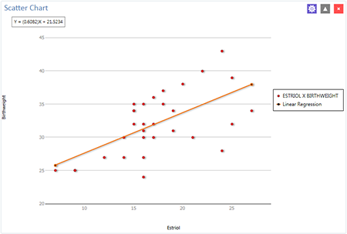
Scatter chart

Epi Curve Chart
Follow the steps below to create an Epi Curve showing the incubation time for an unknown pathogen.
- Open the Ecoli.prj project and select the FoodHistory form.
- Right-click on the canvas and select Add Analysis Gadget > Chart > Epi curve chart. The Epi Curve Chart gadget configuration window opens to the Variables property panel.
- Select OnsetDate from the Main variable drop-down list,
- Click the Labels option to customize chart labels and axes.
- Update the X-axis angle setting to -90. This step will permit the date values to display fully on the X-axis.
Control how the Epi Curve Chart displays on the screen.
- Click the Display button. The Display property panel appears.
- Change the width setting to 1000. If your computer screen is too small, you might need to change the width setting of the chart to a higher number until the system displays the values.
- Click the Legend button. The Legend property panel appears.
- Click the checkmark to select Show Legend.
- Click the Grouping and Sorting button. The Grouping and Sorting property panels appears.
- In the Stratify by list, scroll down, and select the variable Sex.
- Click OK. The Epi Curve chart appears on the canvas. Note that hovering over any bar on the chart will display the date and count for the associated data series.
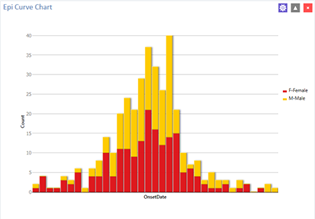
Epi Curve chart

Advanced Statistics

- Logistic Regression
- Logistic Regression Properties
- Complex Sample FTMs
- Complex Sample Frequencies
- Complex Sample Means
- Complex Sample Tables

Linear Regression
Linear regression is an analysis tool that identifies a relationship between a continuous variable and one or more independent variables. It can be used for simple linear regression (only one independent variable), for multiple linear regression (more than one independent variable), and for quantifying the relationship between two continuous variables (correlation). You can use linear regression when you want to determine the relationship between one dependent variable with one or more independent variables.
In the example below, linear regression is used to determine if systolic blood pressure can be predicted based on infant birth weight and age. The dependent variable is systolic blood pressure, and the independent variables are birth weight (in ounces) and age (in days).
- Set the Data Source to the Sample.prj project. Open the BabyBloodPressure form from the Data Source Explorer menu.
- Click OK.
- Right-click on the canvas and select Add Analysis Gadget > Advanced Statistics > Linear Regression. The Regression Properties gadget configuration window opens to the Variables property panel. (See the subsequent Linear Regression Properties section for a screen shot of the gadget.)
- Select SystolicBlood from the Outcome Variable drop-down list,
- Select AgeInDays and Birthweight from the Independent variables drop-down list.
- Click OK. The linear regression results appear on the Visual Dashboard canvas.
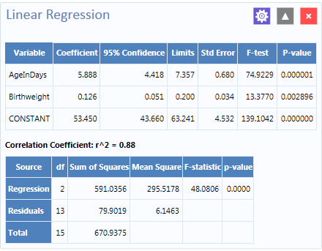
Linear Regression results
Coefficients for both independent variables are positive, and the F-statistic associated with each independent variable is highly significant (p-value less than 0.01). These results suggest that each variable (AgeInDays and Birthweight) is a predictor of higher systolic blood pressure.

Linear Regression Properties
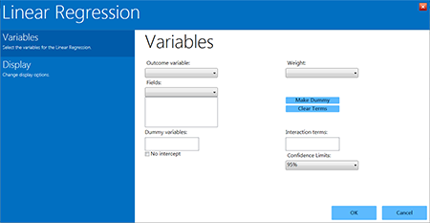
Linear Regression gadget
Linear Regression Gadget settings and elements:
- The Outcome variable — the dependent variable for the regression. The outcome variable must be numeric or a Yes/No field.
- Weight variable — use in weighted analyses.
- Confidence Limits option — specifies the probability level at which Epi Info™ computes confidence limits.
- No Intercept box — the regression is performed without a constant term, which forces the regression line through the origin.
- Fields drop-down list — contains predictor (independent) variables.
- Predictor variables — appear in the list box below the Fields drop-down. Double-clicking on a variable removes it from the list box.
- Make Dummy button — If you click Make Dummy, the variable appears in the Dummy Variable list box. Double-click on a variable to remove it from the list box.
- Make Interaction button — defines Interaction Terms.
Note: Make Dummy button turns to the Make Interaction button when two or more variables are selected at the same time from the Fields list box (hold the CTRL key to select more than one variable in this list). If you click Make Interaction, the relationship populates the Interaction terms list box. Make Interaction adds all combinations of the selected variables to the regression as interaction terms.

Logistic Regression
In Epi Info™ 7, either the M x N/ 2 x 2 table or Logistic Regression is usable when outcome variables are dichotomous (for example, Ill–Yes/ Ill–No). However, an M x N/ 2 x 2 analysis is useful only when there is one “risk factor,” or explanatory variable. Logistic Regression is useful when the number of explanatory variables (“risk factors”) is more than one. Logistic Regression shows the relationship between an outcome variable with two values and explanatory variables that can be categorical or continuous. To use Logistic Regression, the dependent (outcome) variable must be dichotomous (can be divided into only two parts) Yes/No or numeric 0/1. The independent variable can be numeric, categorical, or Yes/No variables.
Records with missing values are excluded from Logistic Regression analyses. If the Include Missing option is used with missing values and Yes/No fields, dummy variables will generate automatically, contributing Yes vs. Missing and No vs. Missing. Independent variables of text type are automatically turned into dummy variables, which compare each value relative to the lowest value in the sort order. Date or numeric type independent variables are treated as continuous variables unless they are set as dummy variables, which compare each value relative to the lowest value.
The following example uses logistic regression to determine the odds ratio of six foods that could be the cause of a hypothetical foodborne illness. The dependent variable is Ill, and the independent variables are brown bread, cabbage, water, milk, chocolate, and vanilla.
- Set the Data Source to the Sample.prj project. Open the Oswego form from the Data Source Explorer menu.
- Click OK.
- Right-click on the canvas and select Add Analysis Gadget > Advanced Statistics > Logistic Regression. The Logistic Regression gadget configuration window opens to the Variables property panel. (See the subsequent Logistic Regression Properties section for a screen shot of the gadget.).
- Select ILL from the Outcome drop-down list.
- Select BROWNBREAD, CABBAGESAL, WATER, MILK, CHOCOLATE, and VANILLA, from the Independent variables drop-down list.
- Click OK. Results appear on the Visual Dashboard canvas.
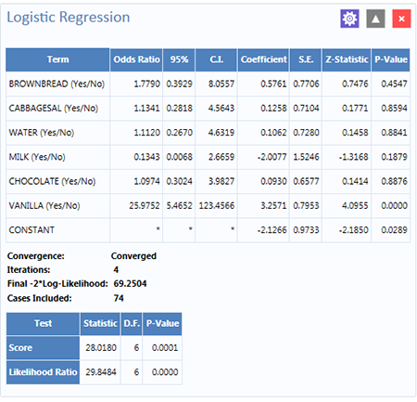
Logistic Regression Properties
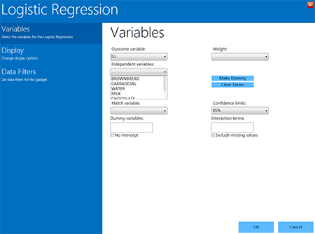
Logistic Regression gadget
- Outcome variable — is the dependent variable for the regression. The outcome variable must be numeric or a Yes/No field.
- Weight variable — may be selected to use in weighted analyses.
- Match variable — identifies the variable indicating the group membership of each record.
- Confidence limits — option specifies the probability level at which Epi Info™ computes confidence limits.
- No intercept box (checked) — the regression is performed without a constant term.
- Include missing values — controls independent variables. If Include missing values is used with missing values and true/false, dummy variables will be created automatically. This will contribute Yes vs. Missing and No vs. Missing. Independent variables of text type are automatically turned into dummy variables that compare each value relative to the lowest value in the sort order. Date or numeric type Independent variables are treated as continuous variables unless designated as dummy values using the Make dummy button. If that occurs, they automatically turn into dummy variables, which compare each value relative to the lowest value.
Note: The Independent variables drop-down list contains the predictor (independent) variables.
Note: When selected, the predictor variables will appear in the list box below the Independent variables drop-down. Double click on a variable to remove it from the Other variables list box. Select a variable from the Independent variables list box to activate the Make Dummy button. If you click Make dummy, the selected variable will then appear in the Dummy variables list box. Doubl-click on a variable to remove it from the Dummy variables list box.
- Make interaction button — defines Interaction terms list box.
- Make dummy button — turns to Make interaction when two or more variables are selected at the same time from the Fields list box (hold the CTRL key to select more than one variable in this list). If you click Make interaction, the relationship populates the Interaction terms list box. Make interaction adds all combinations of the selected variables to the regression as Interaction terms. Double-click on a variable to remove it from the Interaction terms list box.
- Clear terms button — clears all variables from the Dummy variables and Interaction terms list boxes.

Complex Sample Frequencies, Tables, and Means
The Frequency, Table, and Means options in Epi Info™ 7 perform statistical calculations assuming the data were collected using simple random sampling or unbiased systematic sampling. Many surveys also make use of more complex sampling strategies such as stratification, cluster sampling, and the use of unequal sampling fractions. Visual Dashboard provides three options to analyze complex sample data: Complex Sample Frequencies, Complex Sample Means, and Complex Sample Tables.
Generally, in complex sample analysis, there is a variable for the primary sampling unit (PSU) or Cluster from which a sample subject was selected. If the PSUs were chosen from different Strata (e.g., states or counties), there may be a stratification variable (Stratify by). The concept of sample stratification in complex sample design differs from the concept of stratification during epidemiologic analysis using the TABLES command, as the Strata are chosen in the sampling process before analysis. In addition, a weight variable (Weight) is used when sampling strategies result in unequal selection probabilities. The complex sample commands in Epi Info™ 7 can compute proportions or means with standard errors and confidence limits. If a 2×2 table is requested, the odds ratio, risk ratio, and risk difference are provided.

Complex Sample Frequencies
The Complex samples frequencies option produces frequency tables for selected variables. The Sample project contains an Expanded Program for Immunization (EPI) cluster survey. Using the EPI method, a team selected 30 communities (i.e., clusters) from the chosen geographic area and visited each of the 30 communities. In each, they selected seven children in an appropriate age range and determined each child’s immunization (VAC) status. The following example will determine the frequency of vaccinations using Complex Sample Frequencies.
- Set the Data Source to the Sample.prj project.
- Select the Epi1 form from the Data Source Explorer menu.
- Right-click on the canvas and select Add Analysis gadget > Advanced statistics > Complex sample frequencies.
The Complex Sample Frequencies configuration window opens to the Variables property panel.
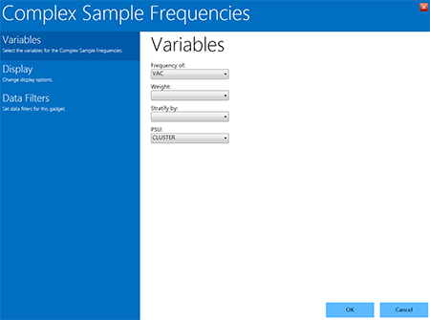
Complex Sample Frequencies gadget
Complex Sample Frequencies options are:
- Frequency of — identifies the variable(s) whose frequency is computed.
- Weight variable — selected for use in weighted analyses.
- Stratify by — identifies the variable to be used to stratify or group the frequency data.
- The PSU — identifies the Primary Sampling Unit.
- Select VAC (the number of vaccinations received) from the Frequency Of drop-down list. This will calculate the frequency of vaccinations in the data set.
- Select CLUSTER (the population group for each case) from the PSU drop-down list.
- Click OK.
The Complex Sample Frequencies appear on the canvas.
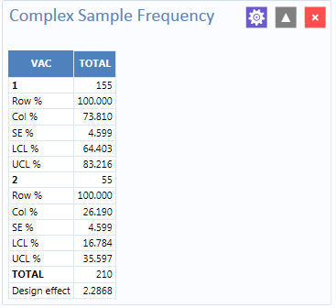
Complex Sample Frequencies results
Information provided in the output includes:
- Row % — the row percentage; frequency will always be 100% because the total number of cases will always be 100%.
- Col % — the column percentage. This number represents the frequency computation; in this case, children with 1 vaccination represent 73.810 % and children with 2 vaccinations represent 26.190% out of the 210 total cases.
- SE % — the standard error, which considers the complex sample design.
- LCL % — Lower Confidence Limit.
- UCL % — Upper Confidence Limit.
- Total — Total number of individuals/elements surveyed.
The results indicate that 73.8% of the 210 children surveyed are vaccinated, with a 95% confidence interval range from 64.4% to 83.2%.
The following example is like the one above, except that this is a stratified cluster survey with a separate 30-cluster survey completed in each of 10 strata. To analyze this dataset correctly, we will consider where each child lives (LOCATION). We will also use a weight variable to account for the differences in population sizes between the different locations.
- Set the Data Source to the Sample.prj project.
- Select the Epi10 form from the Data Source Explorer menu.
- Right-click on the canvas and select Add Analysis gadget > Advanced statistics > Complex sample frequencies.
The Complex Sample Frequencies configuration window opens to the Variables property panel.
- Select VAC from the Frequency Of drop-down list.
- Select POPW (the percent of the total population in each cluster) from the Weight drop-down list.
- Select LOCATION from the Stratify By drop-down list.
- Select CLUSTER from the PSU drop-down list.
- Click OK.
The Complex Sample Frequencies results appear on the canvas.
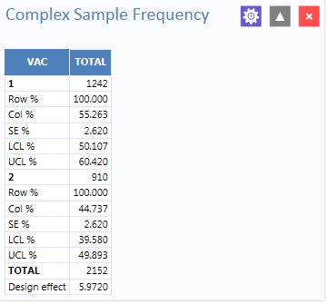
Complex Sample Frequencies stratified and weighted results
The results indicate that 55.3% of the 2,152 children surveyed are vaccinated, with a 95% confidence interval range from 50.1% to 60.4%.

Complex Sample Means
The Complex Sample Means command can be used when the outcome variable is continuous, such as age, cholesterol level, and so on. You can either calculate an overall mean with its measures of variation or compare means across a grouping variable. As an example of calculating means with a grouping variable, use the data from the Smoke form located in the Sample project folder. In this example, the investigator is interested in determining if, among smokers, there is a difference in the average number of cigarettes smoked between males and females. In these data, the variable SEX is coded as 1=male and 2=female.
- Set the Data Source to the Sample.prj project.
- Select the Smoke form from the Data Source Explorer menu.
- Right-click on the canvas and select Add Analysis gadget > Advanced statistics > Complex sample means.
- The Complex Sample Means configuration window opens to the Variables property panel.
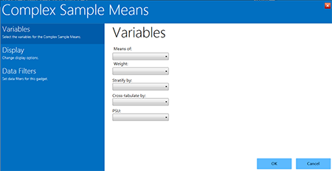
Complex Sample Means gadget
Complex Sample Means options:
  - Means of identifies the variable for which the mean is computed.
  - A Weight variable is selected for use in weighted analyses.
  - Stratify by identifies the variable for grouping the frequency data.
  - Cross-tabulate by identifies the variable to cross-tabulate the main variable.
  - The PSU identifies the Primary Sampling Unit.
- Select NUMCIGAR (number of Cigarettes smoked), from the Means Of drop-down list.
- Select SAMPW (calculated based on sample size and population size) from the Weight drop-down list.
- Select Strata, from the Stratify By drop-down list.
- Select Sex from the Cross-tabulate By drop-down list.
- Select PSUID, from the PSU drop-down list.
- Click OK.
- The Complex Sample Means results appear on the canvas.
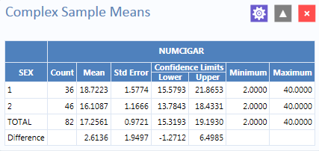
Complex Sample Means results
The results indicate that among the 82 individuals who smoked cigarettes, the average number of cigarettes smoked per day (NUMCIGAR) for men was 18.7, and 16.1 for women, with a 95% confidence interval range of 15.6 to 21.8 for men and 13.7 to 18.4 for women. Note that the Smoke file has 337 individuals (this value is shown in the upper right-hand corner of the canvas). However, the number of cigarettes smoked per day has data for only the 82 smokers. For nonsmokers, this variable was left blank and is therefore treated as missing data and excluded from analysis.

Complex Sample Tables
The Complex Sample Tables option in Visual Dashboard allows you to specify an Exposure Variable and an Outcome Variable. The following example uses Complex sample tables to show whether the mother receiving prenatal care (PRENATAL) influences the child’s vaccination status. If the mother had received prenatal care, PRENATAL=1, else PRENATAL=2.
- Set the Data Source to the Sample.prj project.
- Select the Epi10 form from the Data Source Explorer menu.
- Right-click on the canvas and select Add Analysis gadget > Advanced statistics > Complex sample tables.
The Complex Sample Tables configuration window opens to the Variables property panel.
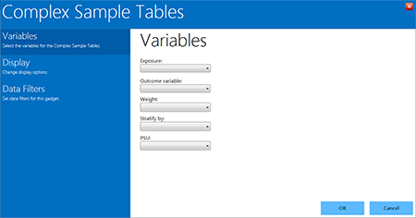
Complex Sample Tables gadget
Complex Sample Tables options:
  - Exposure identifies the variable that displays on the horizontal axis of the table. It is considered a risk factor.
  - Outcome Variable identifies the variable that displays on the vertical axis of the table.
  - A Weight variable is selected for weighted analyses.
  - Stratify by identifies the variable for grouping the frequency data.
  - The PSU identifies the Primary Sampling Unit.

Select the following from the sequential drop-down lists:
- PRENATAL from the Exposure drop-down list,
- VAC from the Outcome drop-down list.
- POPW (the percent of the total population in each cluster) from the Weight drop-down list.
- Location from the Stratify By drop-down list.
- Cluster from the PSU drop-down list.
- Click OK.
- The Complex Sample Tables results appear on the canvas. You may need to scroll down to see the full results.
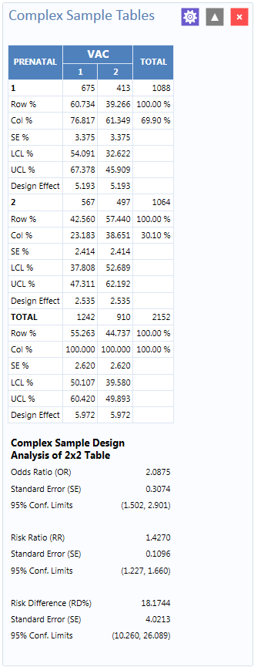
Complex Sample Tables results
The results show that 60.7% of children whose mothers received prenatal care were vaccinated, compared to 42.6% of those children whose mothers did not receive prenatal care.
The 2 x 2 data shows that the odds ratio in the data was 2.088, the risk ratio was 1.427 and this risk difference is 18.2%. The prevalence (risk) ratio indicates that 1.427 times as many children of women who received prenatal care were vaccinated (60.734% divided by 42.560% = 1.427), compared to children born to women who had not received prenatal care; a 40% difference.

Gadget Configuration Settings
You can move gadgets around the screen wherever you like. Each gadget contains three buttons located in the top-right corner. These icons are:
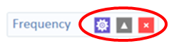

Gadget widgets
Change Gadget Properties: Use to review configuration set which fields the gadget will process.
: Collapse/Expand Gadget Output: Use to collapse and expand the gadget’s output.
: Close: Removes the gadget.

The Change Gadget Properties button opens the gadget’s configuration window including gadget filters. The Collapse/Expand button gray up/down arrow on the gadget’s header panel enlarges and reduces the gadget’s output. This button removes the output from each gadget. Clicking on the red X, closes the gadget. Confirm the removal of the gadget from your canvas.

Line List
The Line List gadget displays the variables of the current dataset with their corresponding values. You can select specific variables from the variables box to narrow the list or press CTRL+A to select all the variables. Selecting a group or a page will show the variables contained in the group or page, respectively.
Follow the steps below to create a line list.
- Load the Sample.PRJ project located in the Epi Info™ 7\Projects\Sample folder.
- Select Oswego. Seventy-five (75) records should be listed in the Record Gadget window.
- Right-click a blank portion of the Dashboard canvas. A context menu appears.
- Select Add Analysis Gadget > Line list from the context menu. The line list gadget appears.
- From the Variables section, use CTRL+Left Click to multi-select the following fields:
- Age
- DateOnset
- Sex
- Timesupper
- Ill
- Water
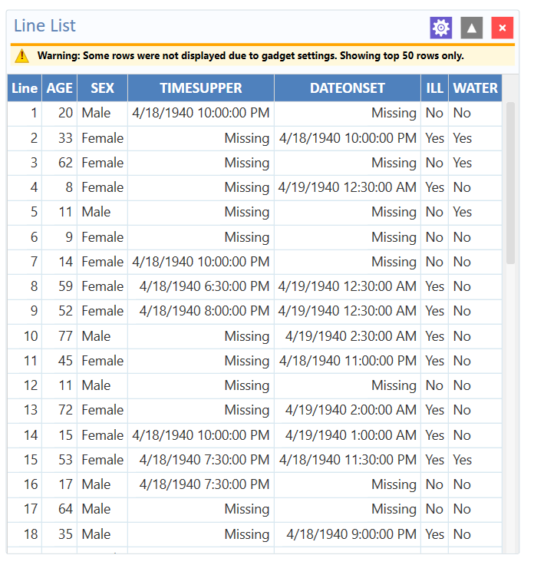
Line List Fields
Notice the warning message showing at the top of the output. The warning states that the output is limited to 50 rows due to a gadget setting. The row limit prevents you from accidentally generating a line list of hundreds of thousands of records (which would greatly impair performance).
To modify this setting, follow the steps below:
- Click the gear icon to show the Line List Properties panel.
- Click on Display.
- Change the Max rows to display from 50 to 100
- Click OK.

The line list frequency output is re-generated with all the records displayed.
For example, if you want to sort the line list by Age, complete the following steps:
- Click the gear icon to show the Line List Properties panel.
- Click on the Grouping and Sorting section.
- Select Ascending from the Method drop-down list.
- Double-click on Age in the Available Variables box.
- Click OK. The line list is sorted by Age.
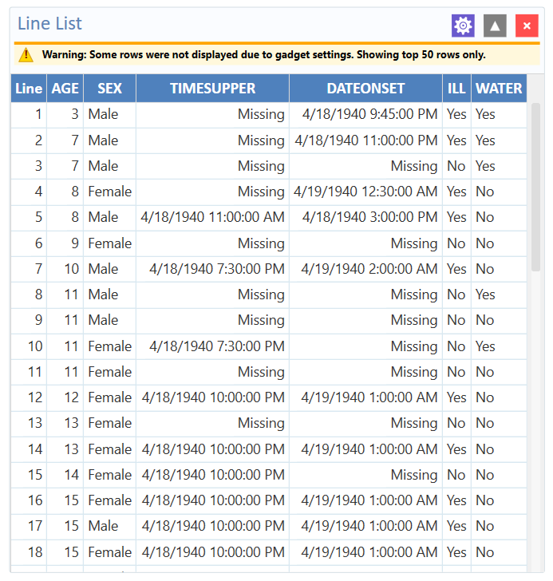
Line List

Moving and collapsing the Line List
The Line List gadget can be dragged around the canvas by left clicking on it, holding the left mouse button down, and then dragging the mouse. Gadgets can be placed anywhere, including on top of other gadgets.
Note: Attempting to drag the line list by clicking on the list’s output and moving the mouse may not work. If this occurs, try clicking the gadget’s header and moving the mouse instead.
Clicking the icon will collapse the contents of the line list output without close the line list. The benefit to collapsing output is more apparent when many gadgets are on the canvas at once.

Sending line list output to other programs
You can send the line list output to other programs or copy it to the clipboard. To send the line list data to Microsoft Excel, follow the steps below:
- Right-click on the output for the line list gadget. A gadget-specific context menu appears.
- Select Send list data to Excel. The line list data appears in Microsoft Excel after several moments.
If your computer does not have Microsoft Excel installed, you can select Send list data to web browser. Another option on the context menu, Copy list data to clipboard, allows you to paste the list output into other Windows applications. For most gadgets, you can send gadget data to the web browser, to Excel, and add it to the clipboard.

Frequency
The Frequency gadget produces a table that shows how many records have a value for each variable, the percentage of the total, and a cumulative percentage. You can select multiple variables with a single frequency gadget by pressing CTRL-click.
Follow the steps below to show a frequency of gender:
- Load the Sample.PRJ project located in the Epi Info™ 7\Projects\Sample folder.
- Select Oswego. Seventy-five (75) records should be listed in the Record Gadget window.
- Right-click on a blank portion of the Dashboard canvas. A context menu appears.
- Select Add Analysis Gadget > Frequency from the context menu. The frequency gadget appears.
- Click on ILL from the list of variables.
- Click OK. The frequency is displayed.

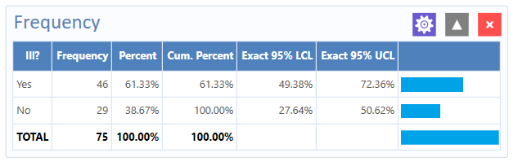
Frequency Fields
The Frequency column provides the count of individuals that were ill and not ill. The Percent column indicates the percentage of who were ill or not ill.
The 95% Confidence Limits are a range of values that indicates the likely location of the true value of a measure, meaning (in this instance) that the number of ill could be as low as 49.38%, or as high as 72.36%.
Note: The Yes Ill percentage of 61.33% falls within the 95% Confidence Limits range of values based on the data.
You can stratify frequency output. To stratify the gender frequency by Ill, follow the steps below:
- Click the gear icon to show the Frequency Properties panel.
- Click on Grouping and Sorting section.
- Select Sex from the Stratify by list.
Click OK. The frequency output is re-generated with stratified output.
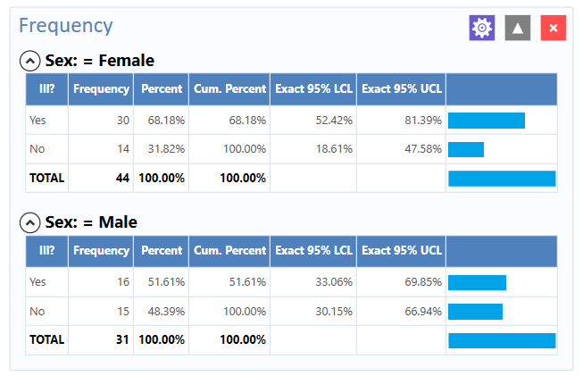
Frequency Output by Sex

Additional Frequency Gadget Properties
The following options are available in the Frequency gadget properties panel shown in Figure 68.

Variables
- Frequency of: The field on which to run the frequency.
- Weight: The field to use as the weight variable, for example if aggregate data is being analyzed.

Grouping And Sorting
- Stratify by: The field to use for stratifying the output.
- Sort high to low: Sorts the output from highest frequency to lowest when selected. When cleared, the output is generally sorted alphabetically.

Display
  - Gadget Title: Allows specific text to be displayed in the header of the gadget.
  - Gadget Description: Allows specific text to be displayed as a description of the gadget.
  - Display all list values: Only applicable when the frequency variable is a drop-down list field in an Epi Info™™ 7 project. When selected, the output will show all of the drop-down list values even if they have a count of zero.
  - Display list labels: Only applicable when the frequency variable is a Comment Legal field or Option Field in an Epi Info™™ 7 project. When selected, the output will show the code and the code description for Comment Legal fields. For Option fields, the label is displayed.
  - Include missing values: If selected, missing values are included in the output.
  - Use field prompt: Only applicable when the frequency variable is a field in an Epi Info™ 7 project.
If checked, the field prompt will appear as the column heading instead of the field name.
- Draw borders: Setting for drawing the frequency border. Draw header row: Setting for displaying the frequency headers.
- Draw total row: Setting for displaying the frequency totals.
- Decimals to display: Specifies number of decimal places to display.
- Maximum rows to display: Specify number of rows to display.
- Max width of percent bar: Width for percent bar column using a % value.
- Output columns to display: Determines which columns in the output are shown. By default, all columns are selected for display.

Data Filters
- Allows setting the data filters for a gadget. 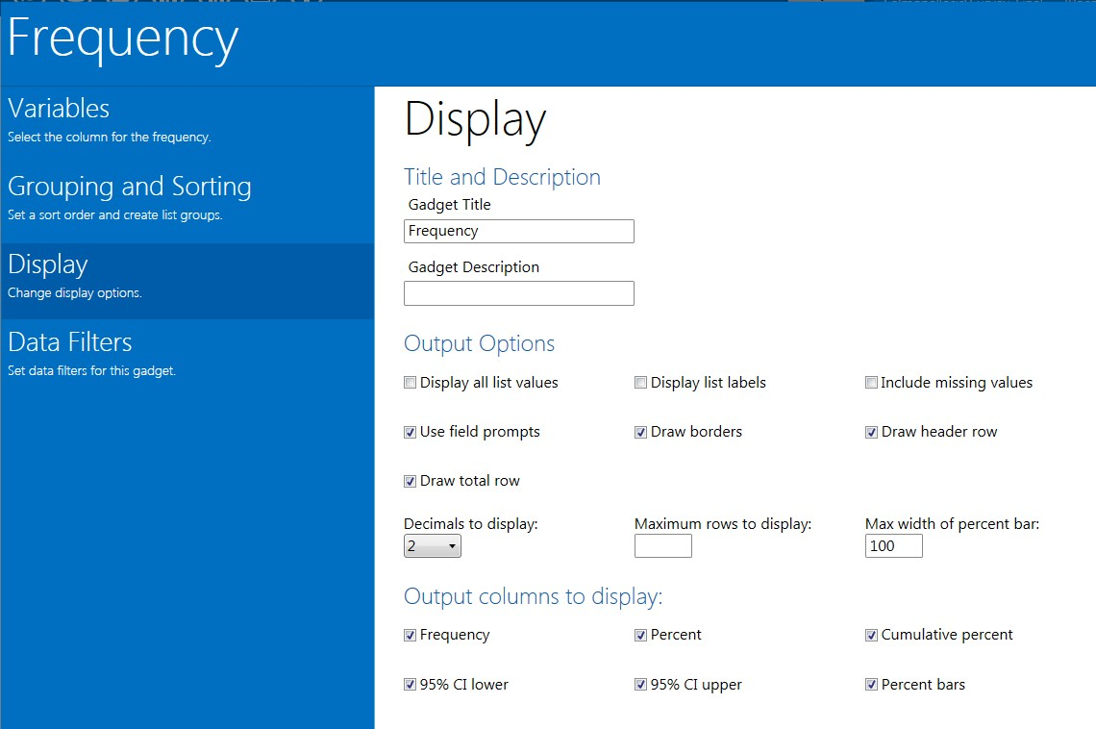
Frequency Title and Description

Means
The Means gadget can obtain the Sum, Total, and/or the average of values for a continuous numeric variable. Since it only works with numbers, the variable must be numeric, date, or time. The results include the total number of observations (Obs); the sum of all observations (Total); the mean, variance, and standard deviation (Std Dev) of the observations; minimum and maximum values; 25th, 50th (median), and 75th percentiles; and the mode. If the variable has two or more values (a tie) for the mode (most frequent) value, the smallest will be presented in the Epi Info™ output. If only one variable is supplied, the Means gadget produces a table with descriptive statistics. If two variables are supplied, the first is numeric containing data to be analyzed. The second indicates how groups will be distinguished. The output of this format is a table with descriptive statistics of the numeric variable for each group variable value.
Follow the steps below to show descriptive statistics for the Age variable:
- Load the Sample.PRJ project located in the Epi Info™ 7\Projects\Sample folder.
- Select Oswego. Seventy five (75) records should be listed in the Record Gadget window.
- Right-click on a blank portion of the Dashboard canvas. A context menu appears.
- Select Add Analysis Gadget > Means from the context menu. The means gadget appears.
- Select Age in the Means of: drop-down list.
- Click OK.
The summary statistics for Age are displayed. Notice the mean age of individuals in the dataset is 36.8.
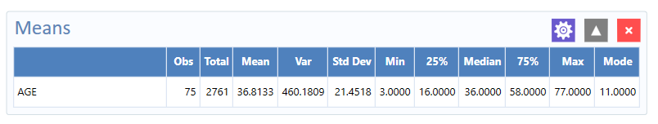
Stats for Age
For the next example, use a numeric variable or a Yes/No variable to determine the Means for a group.
- Right-click on a blank portion of the Dashboard canvas. A context menu appears.
- Select Add Analysis Gadget > Means from the context menu. The means gadget appears.
- Select Age in the Means of: drop-down list.
- Select ILL from the Cross-Tabulate by Value of drop-down list,.
- Click OK.
Notice the Mean Age of those answering Yes to ill is 39.2. Those answering No to ill is 32.9.
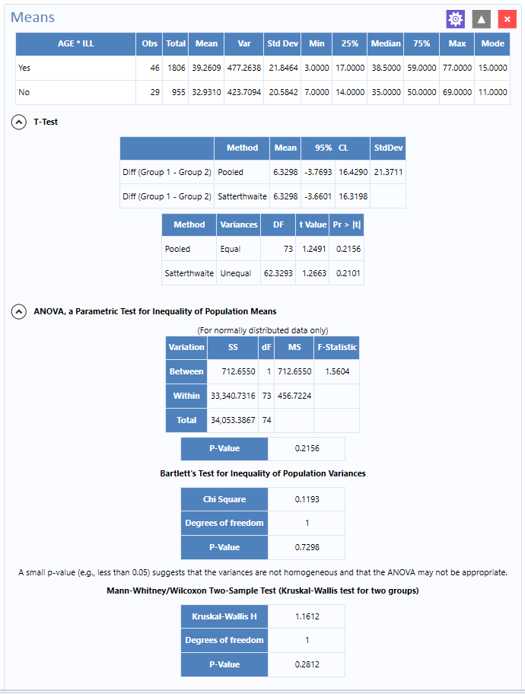
Means for Age
When comparing two means an independent t-test is performed, and for comparing more than two means, a one-way analysis of variance (ANOVA) is performed. You can use the independent t-test and ANOVA if the following assumptions are met:

- The outcome variable is normally distributed in each group.
- The underlying variances are the same in each group.
Epi Info™ does not provide a statistical test to determine the normal distribution of data; graph the data to visually detect normal data distribution. Epi Info™ does perform a test to determine if the second assumption above is met called “Bartlett’s Test”; if the p-value is large (say > 0.05) this would suggest the variances are approximately equal; if the p-value from Bartlett’s test is small (say < 0.05), this suggests that the underlying variances are not the same and therefore the t-test and ANOVA results may not be appropriate for the data.

MxN/2x2 Table
The MxN/2x2 Table gadget examines the relationship between two or more categorical values. For 2×2 tables, the gadget produces odds and risk ratios. A 2×2 table is created when each selected variable has a Boolean or Yes/No answer value.
Create a 2×2 table using data from the Sample.MDB project.
- Read in the Sample.PRJ project located in the Epi Info™ 7\Projects\Sample.
- Select EvansCounty.
- Six hundred (600) records should be listed in the Output window.
- Right-click on a blank portion of the Dashboard canvas. A context menu appears.
- Select Add Analysis Gadget > MxN/2x2 Table. The gadget appears.
- Select CAT From the Exposure Variable drop-down list.
- Select CHD From the Outcome Variable drop-down list.
- Click OK. Results are generated.
The variable CAT corresponds to catecholamine while the variable CHD corresponds to coronary heart disease. The output for two Yes/No variables, shown below, is a 2-by-2 table that contains: the number of observations in each cell, the row percent (Row %), and the column percent (Col %). You can adjust Row and Column percents to on or off from the SETTINGS command, the last one in the command list.
View the graphic at the right of the table. It depicts how the distribution of observations within the table – the larger the box, the larger the number of observations.
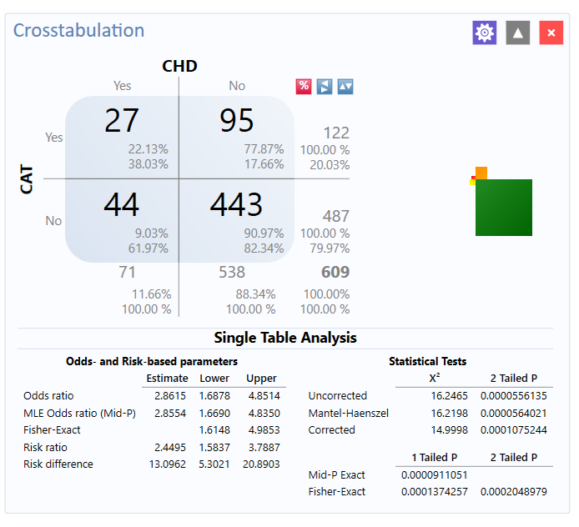
Crosstabulation and Analysis
The small red box represents the upper left cell of the table, the ill persons with exposure to the risk factor. The large green box on the lower right represents the persons who were not ill and did not have the specified exposure. Both boxes are in favor of the hypothesis that there is an association between exposure and illness. The other two boxes in the upper right and lower left are discordant with the hypothesis.
The odds ratio, one of the measures of association, can be thought of as red x green divided by brown x yellow, or the product of boxes in favor divided by the product of boxes against the association. If the boxes against predominate, then the exposure may be protective (odds ratio less than 1.0). If the red and green boxes (upper left and lower right) win the day, the odds ratio exceeds 1.0, and there is a positive association. If all the boxes are the same size or the two cross-products are equal, the odds ratio is 1.0, suggesting no association.
Beneath the table is the Single Table Analysis that shows parameter estimates with confidence intervals and statistical tests. The first set of parameter estimates are based on the odds, with an odds ratio based on the cross product [i.e., (a x d) / (b x c)], and one based on the maximum likelihood estimation approach (MLE). View the three different confidence intervals; the Taylor series, mid-P exact, and the Fisher exact.
Next are the Risk-based estimates - the risk ratio and the risk difference with their confidence intervals.
Note: If the outcome variable is based on prevalent disease, then substitute the terms “prevalence ratio” and “prevalence difference” for “risk ratio” and “risk difference”, respectively.
Finally, several statistical test results are provided: three different chi square tests and two exact tests. The chi square tests are presented as two-tailed p-values (although you could divide the two-tailed p-value by 2 to calculate a one-tailed p-value), and the exact tests are presented as one-tailed p-values (you could multiply the one-tailed p-values by 2 to get a two-tailed p-value).

Data Dictionary

Show Data Dictionary
The Data Dictionary displays form(s) and defined variables for the current Data Source. Fields or variables sort and display by page number in the form (if using an Epi Info project as the data source). Defined variables appear at the end of the listing. Information retrieved from the form includes Field Name, Prompt, Form, Page, Tab, Data Type, Epi Info™ Field Type, and Table.
- Right-click on the canvas and select Show Data Dictionary.
- The Data Dictionary displays on the canvas.
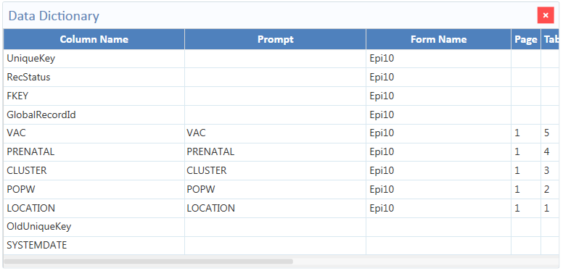
Data Dictionary view
Use the scroll bar at the bottom of the Data Dictionary to view the rest of the window. Column values for Prompt, as well as Data Type and Epi Field Type (both of which are viewable when the user scrolls right) populate when fields are created from the Field Definition dialog box. Review the Form Designer Guide from the collection of Epi Info™ 7 help documentation for more Information.

Open Data Dictionary as an HTML page inside a web browser
Steps:
- Hover over the dictionary window
- Right-click and select Send Data Dictionary to Web Browser.
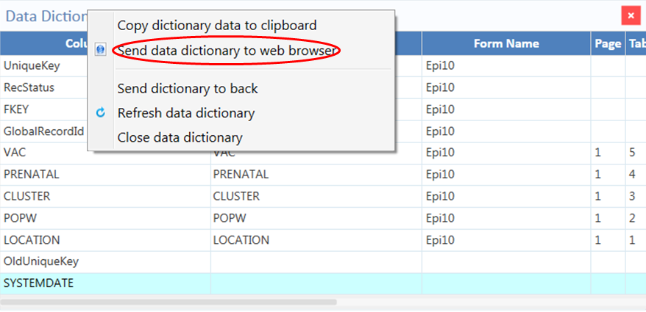
Data Dictionary to Web
- Print web browser content by right-clicking on the page window and selecting print or use the browser options menu. You can also save content from save as in the browser options menu.
- You can export data to an Excel spreadsheet by right-clicking over the table in the web page. The pop-up menu shows Export to Microsoft Excel.
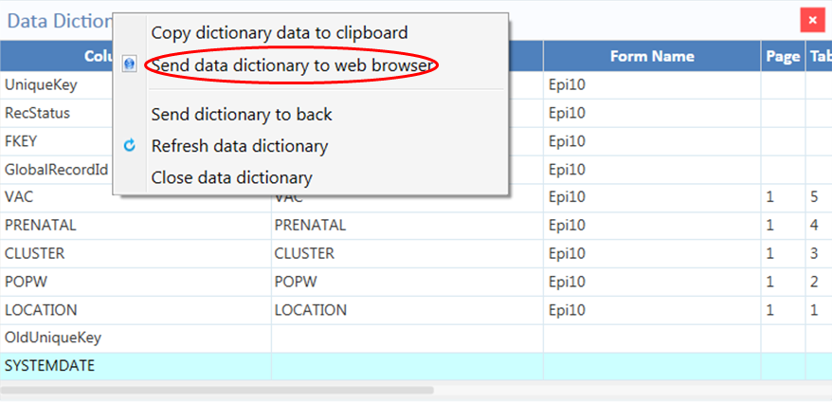
Data Dictionary Export to HTML

- Close the browser window to exit Data Dictionary.
Note: Refresh Data Dictionary at any time so you see the most current data. Right click on Data Dictionary and select Refresh Data Dictionary.

Additional Gadgets for Reports

Simple Text Box and the Image Gadget
These gadgets add text and images to your reports.

Simple Text Box
You to specify several lines of text displaying on the canvas using Simple Text Box. Use these lines of text for annotations, above or beside gadgets on the canvas. Annotations are great for adding titles to the canvas.
Steps:
- Right-click on the Visual Dashboard canvas. Select the Add Report gadget from menu options.
- Select Simple Text box. The text box displays.
- Enter a title or other text. You can move the text box around by clicking on it and dragging the text box to where you want it.
Removing your title:
- Right-click on the text box border.
- Click Close to close this gadget.

Image Gadget
Image Gadget is another report gadget. You can add an image or logo to the canvas.
Steps:
- Right-click on the Visual Dashboard canvas.
- Select Add Report gadget from the menu options, and then select Image gadget. A light blue box displays near your mouse pointer location.
- Click on the light blue box and the Open dialog box displays. Select the location of your image or enter the filename of your image.
Note: You may only select a PNG file for the Image gadget.
- Double-click the image. You can also select it and click Open.
- The image displays on the canvas.
Removing your image:
- Right-click on your image.
- Click Close to c

This page was intentionally left blank.



